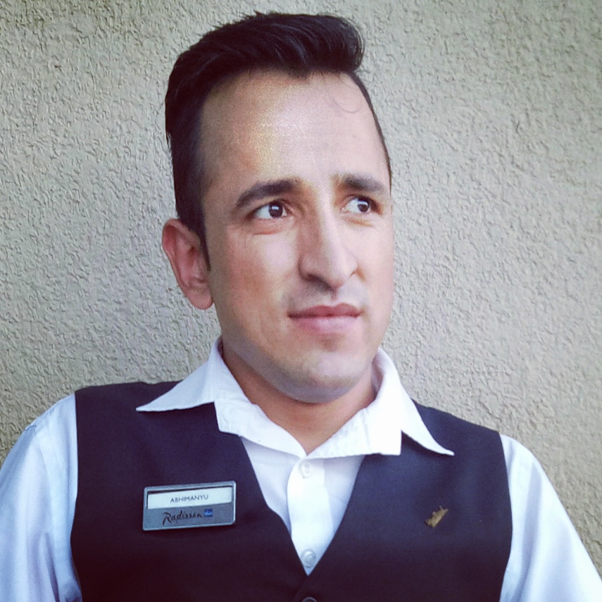

ABHIMANYU KUMAR

Contact Number: +**91-8007620488**

Email id:**rangtanr15@gmail.com**

**Career Objective**

To find a challenging position to meet my competencies, capabilities, skills, education and experience.

***Professional Snapshot***

* **05 years** of rich experience in Food and Beverage Service.
* Outstanding relationship building & presentation skills. Intelligent, articulate & driven to succeed.
* Excellent proficiently performing and excelling under demanding work conditions.
* A constant and quick learner capable of acute concentration for long hours with enthusiasm.
* Stretch self to the fullest to get the assigned work done.

***Core Competencies***

**Skills**

* Excellent in understanding the basic sanitation requirements regarding to food handling, personal hygiene, sanitation and equipment safety.
* Great customer service with the effective communication skills both verbally and written.
* Able to communicate positively with staff and customer.
* Excellent ability to listen to directions and follow all instructions.
* Ability to handle the system (Micros) and the role of cashier also.
* **Relationship Management:** Handling customer queries for better turnaround time and customer satisfaction. Identifying prospective clients, generating business from the existing clientele to achieve business targets

***Employment Account***

***Golden Bambuzzz Restaurant & Bar (Mumbai)***

***As a Restaurant Manager***

***From Nov. 2018 to July 2019***

***Responsibilities :-***

***Coordinate daily Front of the House and Back of the House restaurant operations***

***Deliver superior service and maximize customer satisfaction***

***Respond efficiently and accurately to customer complaints***

***Regularly review product quality and research new vendors***

***Organize and supervise shifts***

***Appraise staff performance and provide feedback to improve productivity***

***Estimate future needs for goods, kitchen utensils and cleaning products***

***Ensure compliance with sanitation and safety regulations***

***Manage restaurant’s good image and suggest ways to improve it***

***Control operational costs and identify measures to cut waste***

***Create detailed reports on weekly, monthly and annual revenues and expenses***

***Promote the brand in the local community through word-of-mouth and restaurant events***

***Recommend ways to reach a broader audience (e.g. discounts and social media ads)***

***Train new and current employees on proper customer service practices***

***Implement policies and protocols that will maintain future restaurant operations***

***Radisson BLU Pune Hinjewadi (Pre-Opening)***

***As a Team-Leader Food & Beverage***

***From 10th Sept. 2016 to 9th Oct. 2018***

**JOB RESPOSIBILITIES**

**Guest Satisfaction:**

Follow the best practices to enhance guest experience and guest loyalty towards organization. Interact with the guest take feedback and provide best possible solutions to the guest concern so that guest leaves with positive impression on their mind about the organization. Carry out comment card analysis survey to analyse customer trends and corrective actions to improve the processes. Carry out competitive analysis to be abreast with local competitors about food and beverages trends.

**Brand Standards:**

Develop plans of best practices to carry out smooth functioning of outlets. Educate all team members on touch points of audit requirements. Carry out surprise audits for outlet to maintain the consistency in the service flow. Maintains record of furniture and fixtures to ensure proper maintenance is done.

**Revenue Management:**

Constantly navigate employees to increase the APC of the outlet by up selling the food and beverage products. Plan food and beverage promotions in co-ordination with hotel marketing department and hotel chef to increase the footfall in the outlet. Work closely with food and beverage controllers to maintain the food and beverage cost. Work closely with financial controller to have better control over profit and loss.

**Employee Engagement:**

Create a work culture that is enjoyable and productive. Constantly share feedback on level of performance with employees. Celebrate success of employees and rewards them for their commitment. Work with employees to overcome their weakness and showcase their strengths. Accomplish restaurant human resource objective by recruiting, selecting, orienting, training, assigning, scheduling, coaching, counselling, and disciplining employees.

***COURTYARD BY MARRIOTT (Hinjewadi Pune)***

***As a Food & Beverages Associate***

***From12th May 2014 to 04th July 2015***

**Responsibilities:**

* Welcoming the guests and taking care of their seating arrangements.
* Conversing with each guest to convey them about the food menu and to understand their preferences.
* Taking order and serving drinks before the meals.
* Serving each guest politely and sufficiently, as per their demand.
* Taking special precautions in case of kids and senior citizen.
* Following proper sequence of meal courses.
* Handling the shift in absence of supervisor.
* Handling cash and billing.
* Training subordinate colleagues for up selling and efficient service.

***HOLIDAY INN (Hinjewadi Pune)***

***As a Food & Beverages Associate***

***From 1st May 2013 to 07th May 2014***

**Responsibilities:**

* Reporting to our supervisor.
* Guest handling during different social as well as corporate events.
* Making indent for alcoholic & non-alcoholic beverages and stationary items on a weekly basis.
* Handling casuals (30 on an average) on a daily basis.
* Doing different types of setups for the events and laying buffet.
* Provide excellent service to our guest by maintaining standards, proper hygiene and cleanliness of my working area.

***Education***

* 3years B.sc in Hotel Management Catering Technology and Tourism.
* Passed Higher Secondary from H.P. Board Dharmshala on 2010.
* Got a Diploma in Aviation & Retail Management.

***ITSkills***

* Basic computer operation: Internet, Web Browsing, MS-Office, MS Word, Excel & Power Point
* Food and Beverage Related: Shawman, Micros & Orion.

***Training Programme***

* Successfully completed 22 weeks of Industrial training from **REDISSON BLU JAIPUR (Pre-Opening)**

***Personal Dossier***

|  |  |
| --- | --- |
| FATHER’S NAME: | Mr.VidyaSagar. |
| Address: | Vill.-Jakhnoti, P.O.-Chilala, Tehsil- Chirgaon, Distt.-Shimla. H.P.  Pin Code- 171208. |
| Date of Birth: | 16.01.1992 |
| Marital Status: | Single. |
| Sex: | Male. |
| Nationality: | Indian. |
| Religion: | Hindu. |
| Language Known: | English, Hindi. |
| Height: | 5’8”. |
| Weight: | 62kg. |
| Passport No. | N2532893 |
| Hobby**׃** | Playing Cricket. |
| Passion: | Listening to music. |
|  |  |



Dated: Abhimanyu Kumar