Curriculum Vitae

VAISAKH T V
Personal Profile:  PERSONAL DATA:  Nationality : Indian  Sex : Male  Date of birth : 24/02/1987  Place of birth : Othalur  Religion : Hindu  Marital status : Single  CONTACT DETAILS:  +91 8089500998  +91 8301082018  EMAIL  vaisakhothalur@gmail.com  vysakhtv@rediffmail.com  LANGUAGES KNOWN:  English (Read,Write,Speak)  Hindi (Read,Write,Speak,)  Tamil (Speak, Read)  Malayalam (Native) | VAISAKH T V 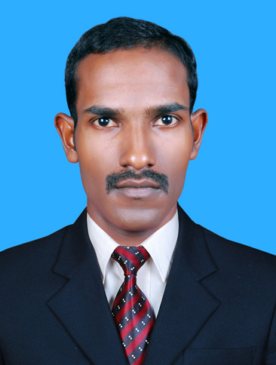  THEKKEPURAKKAL house  (po) OTHALUR  (dist.) malappuram  Kerala, India  pin: 679591  Career Objective:  Looking for a professional and challenging position with opportunities for career development and to grow on the basis of my personal abilities and capabilities to provide productive and efficient services and want to become successful and result oriented.  PERSONAL SKILLS:  - Sincere, hardworking and a commitment to excel in a given field.  - Ability to deal with people diplomatically, willingness to learn.  - Calm confident and ready to take new challenges.  ACADEMIC QUALIFICATION:
  Qualification | Board/Institute/ University | Year  & percentage
  SSLC | Government of Kerala | 2002,55%
  Plus Two | Board of Higher Secondary  Government of Kerala | 2004,60%
  B.Com  M.Com | Calicut university  Madurai Kamaraj university | 2007,48%  2011,55%

Licence DETAILS:  Indian licence No  LMV  46/241/2009  Date of Issue  08/01/2009  Date of Expire  07/01/2029  Personal Interests:  - Travel  - Music  - Cricket  - Football  Personal Strengths:  - Well prepared to adapt to difficult Situation  - Ability to work in a team  FAMILY DETAILS:  Father  Mother  Brother 1  Sister 1 | working experience:  - I have 6 years’ experience in ROYAL SURGICALS as an accountant cum storekeeper since 2008-2014.  - I have 1 year experience in SIMCO as an accountant.  - I worked as an Accountant in ROY ASSOCIATES for a period of 1 year.  - Working as a GST Practitioner since 2018.  (Id: 321800001243GP2)  - I can manage all tax related works and income tax works.  - I can handle all accounts through manual and computerized.  - Accounting all financial transactions in computerized environment using Tally.  - Preparation of Financial statements including Balance Sheet and Profit & Loss Accounts, Income and Expenditure, Receipts and Payments Periodically from Accounting Reports generated from Tally or manually.  - Preparation of Bank Reconciliation statement and pay roll calculation.  - Preparing statement of Accounts on monthly Basis.  - Internal Auditing.  - Income tax return filing.  COMPUTER LITERACY:  - MS .Office 2007, 2010 (word,excel,powerpoint)  - Tally(7.2)  - Tally ERP 9 (accounting software)  - Dac Easy (accounting software)  - Peach Tree (accounting software)  - C –PAC certificate (computerized professional accounting-  course)  COMPETENCIES:  * Earn trust and confidence from others by consistent and reliable behaviour.  * Self-motivated, good team member and committed towards goal.  * Can adopt any kind of environment.  Declaration  I hereby declare that all the fact stated above is true and correct in best of my knowledge and belief.  Sincerely  VAISAKH T V

