**PAVAN SIVA KUMAR CHANDAVOLU** 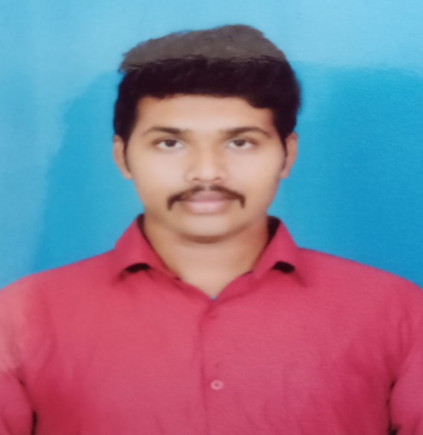

**Email:** pavansiva2411@gmail.com

**Contact No:** 9492120181.

|  |
| --- |
| **CAREER OBJECTIVE** |

I want to work in a company that gives me a chance to prove my abilities and help the company in any way possible. I am an optimistic person who believes in working hard. I have the zeal to prove myself when a task is assigned to me. I have the ability of leading a team. I want the company’s standards and goals to rise with the help of my own contributions.

|  |
| --- |
| **EDUCATIONAL DETAILS** |

|  |  |  |  |  |  |
| --- | --- | --- | --- | --- | --- |
| **S.No** | **Qualification** | **College/Institute** | **Board/ University** | **Year of completion** | **Grade** |
| 1. | 10th | Chegu Vidyalayam | SSC | 2013 | 8.3(CGPA) |
| 2. | Diploma in Mechanical Engineering | Government polytechnic Machilipatnam | State Board of Technical Education | 2017 | 70% |
| 3. | B.Tech(ME) | SET, Jain University | University | 2020 | 7.3(cgpa) |

|  |
| --- |
| **TECHNICAL ABILITY** |

1. Auto cad,
2. Solid edge,
3. ANSYS,
4. MS Office.
5. Linux

|  |
| --- |
| **SKILLS** |

* Digital Marketing
* Content Writing
* Mass media Communication
* Graphic Design
* Social Media Marketing
* Brand Marketing

|  |
| --- |
| **WORK EXPERIENCE** |

I have a work experience of 6 months in Solas Fire Safety Equipment(P) Ltd. I have been lauded for my work by the executives and proved myself to be a better employee both in knowledge as well as in work

|  |
| --- |
| **EXTRA SKILL HIGHLIGHTS** |

* Communication(Written and verbal)
* Strategic and Analytical thinking
* Strong Decision maker
* Leadership
* Project Management

|  |
| --- |
| **ACCOMPLISHMENTS** |

1. Published 3 international journal,

* Assessment of the torsion effect on buildings under lateral seiscmic ground motion,

Publication date Sep, 2017 publication description IJETSR, volume 4, issue 9.

* soil stabilization using plastic,

Publication date Sep, 2017 publication description IJETSR, volume 4, issue 9.

* An absolute self-sustainable residential building,

Publication date Sep, 2017 publication description IJCMS, volume 6, issue 9.

1. Certified as a Material Testing Analyst.
2. Done an internship during Diploma in KCP cement plant Muktyala.
3. Skill Development Program on “Solar Design & Development of Vehicle.
4. Undergone training in “Fire & Safety” conducted by Kings Institute of Fire & Safety.
5. Certification from REDHAT in “Software and Hardware”.

|  |
| --- |
| **EXTRA CIRRICULAR ACTIVITES** |

1. Won 1st prize in painting competition conducted by police department on the occasion of Police Commemoration Day on 21st October 2012.
2. Trained 200 students on the occasion of yoga day on 21st June 2015.
3. Anchored our college farewell day in 2016.
4. Participated in several Blood donating camps.
5. Won 1st prize in Hockey at School of Engineering and Technology Jain University Hostel Sports Meet 2018-2019.

|  |
| --- |
| **PERSONAL DETAILS** |

**Name :** Ch Pavan Siva Kumar.

**Father Name :** Ch. Udaya Bhaskar.

**Date of Birth :** 24/11/1997.

**Address :** D.No: 10-3/6, TF-1, Sri Sai Towers, Transformer Road,

Near Vikas Public School, Prasadampadu,

Vijayawada (Rural), Andhra Pradesh, 521108.

**Hobbies :** Listening to music, playing Hockey and reading novels.

**Languages known :** Telugu, English, Hindi, Kannada.