*Sameer Khan*

ARCHITECTURE STUDENT

I seek a work Design wirh challenges and responsibiliry, o"ering a variarion and scale of projecr in rhe field of archirecrure, urban and planning, A workplace where i can conrribure and rake learn- ing from, simulraneously I would wanr ro explore all avenues of work from research prospecrs ro forming desing srraregies and working on rhe ground of rural/urvan scale and be an inrrumen- ral ream member. I am a candidare who possesses rhe required knowledge and skill-ser preform all rhe jobs, roles and duries confidenrly. given rhe requirmenrs, I am cerrain rhar i have rhe necessary skills ro successfully carry our rhe rasks assigned ro me.

2012- i have completed 10th from CBSE.

2012-2015-I have completed Diploma in Architecture from Chotu ram rural institute of architecture & palnning, Delhi.

2015-2020 I have completed Bachelor in Architecture from Accurate institute of Arcitecture & planning, greater

# 2018

2020

BUILDEYIC hRC"IYECYS € INYERIOR

INTERN ARCHITECT

I have done 4 Months of practical Training. I have worked there in Commercial & residential projects.

WIYYhL hRflOCIhYES, FIYW FURh, DEL"I

INTERN ARCHITECT

I have done 4 months of Practical training. I have done all types of projects there like - commercial,

D-360, jahangir puri, delhi - 11003

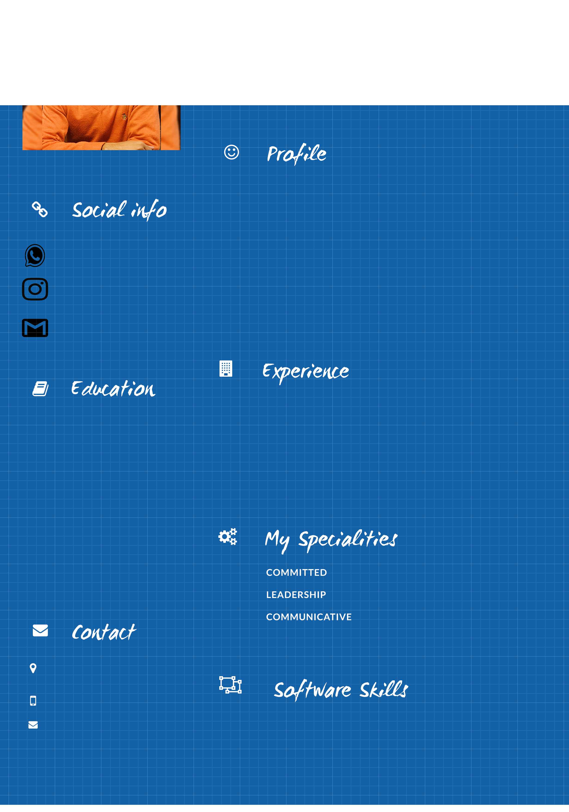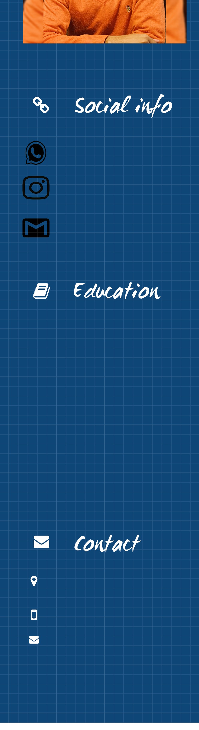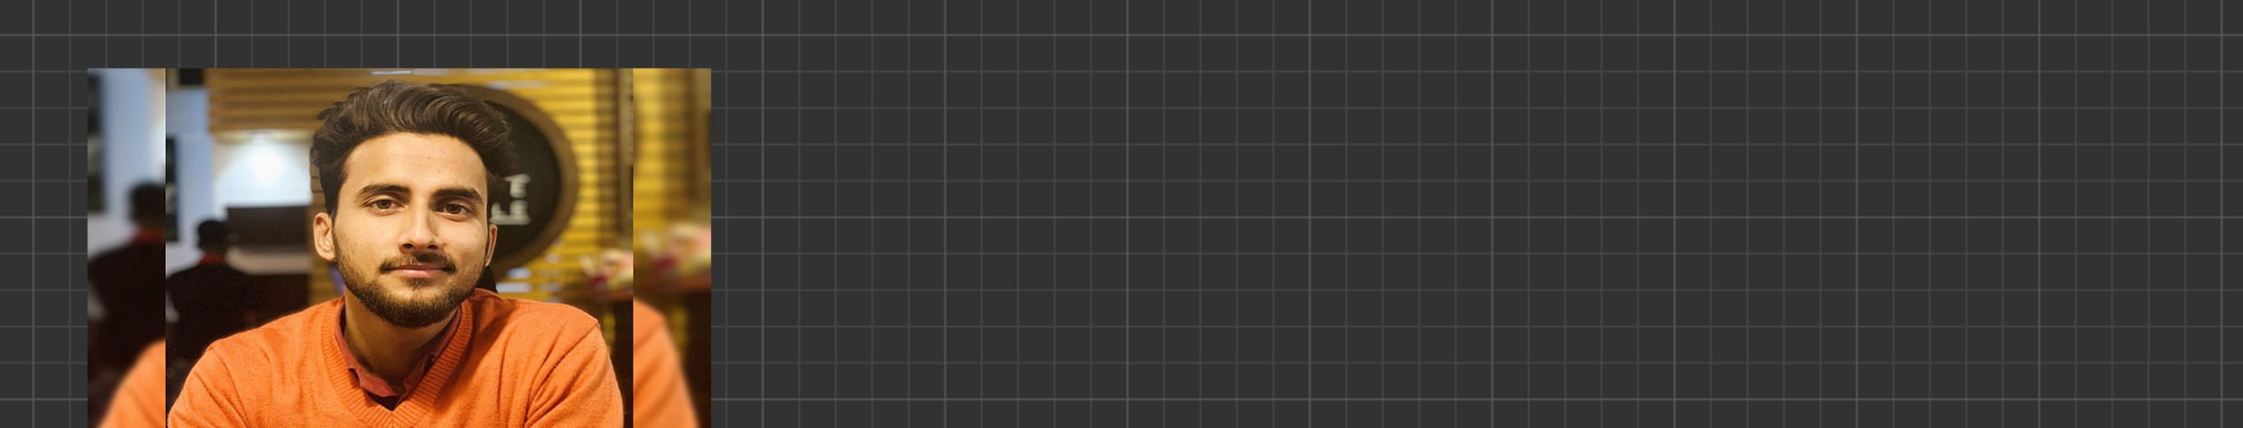

+91-9953168308

[khans.9797@gmail.com.com](mailto:khans.9797@gmail.com.com)

Adobe Photoshop

Autocad

Lumion

Sketchup