**HARPREET SINGH**

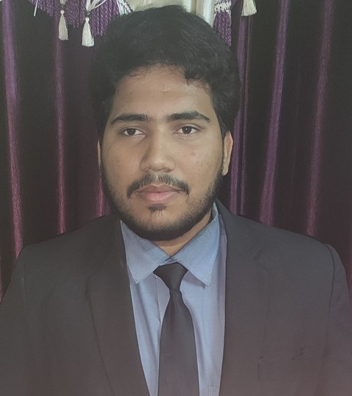

**Phone**: **+917004271432**

**Email**: [amansinghsur@gmail.com](mailto:amansinghsur@gmail.com)

|  |
| --- |
| **CAREER OBJECTIVE** |

Aspring as a successful employee in an emmitted company where my skills and abilities can be set to test. believes in active participation and hard work with learning.

|  |
| --- |
| **ACADEMIC BACKGROUND** |

|  |  |  |  |  |
| --- | --- | --- | --- | --- |
| **Year(s)** | **Qualification – Degree / Diploma / Certificate** | **Board/University** | **College / Institute** | **Percentage / CGPA** |
| 2020 | Diploma, Electrical and Electronics Engineering | A.J.U.JAMSHEDPUR | Arka Jain University | 8.09C.G.P.A. |
| 2017 | 12th | J.A.C | Asanboni Inter College, Asanboni | 50% |
| 2013 | 10th | C.B.S.E | Atomic Energy Central School,Turamdih | 5.6C.G.P.A. |

|  |
| --- |
| **TRAININGS & PROJECTS UNDERTAKEN** |

**Summer Internship Project (Diploma) Duration: 2Weeks (May to June)**

**Company: UCIL TURAMDIH**

**Project Title: Study of Industrial Automation inside the mines**

**Description:** Industrial automation is the **use of control devices such as PLCs/HMIs etc**. to control industrial processes and machinery by removing as much labor intervention as possible, and replacing dangerous assembly operations with automated ones.

|  |
| --- |
| **EXPERIENCE** |

**FRESHER**

|  |
| --- |
| **SKILLS** |

**Personal Strengths:** Decision Making , Problem Solving , Hard Working , Team Work, Passionate Worker

**Hobby:** Listening Music, Play Cricket , Cooking , Travelling , Parasailing , Rock Climbing

**Languages:** Hindi and English, Punjabi

|  |
| --- |
| **COMPUTER PROFECIENCY** |

Operating Systems : Windows (98/2000/XP/7/8/8.1/10

Software Skill : MS Office (Word, Excel, PowerPoint)

|  |
| --- |
| **PERSONAL DETAILS** |

Date of Birth : 29/07/1997

Father’s Name : Shri-Surjit Singh

Mother’s Name : Smt-Rajpal Kaur

Category : General

Gender : Male

Nationality : Indian

Home Town : Jamshedpur , Jharkhand

Permanent Address : C/O: Surjit Singh ,Qr .No–B-3/18 UCIL Colony Turamdih , Near Atomic

Energy Central School Turamdih , P.O.- Sundernagar , P.S.- Sundernagar ,

Turamdih , East Singhbhum, Jharkhand -832107

Permanent Phone No. : 7004271432

|  |
| --- |
| **DECLARATION** |

**I, Solemnly, declare the above mentioned information is true to the best of my knowledge.**

**Harpreet Singh**