**CURRICULAM VITAE**

**SUMITKUMAR M SARVAIYA**

# (Email: [sm.sarvaiya90@gmail.com](mailto:sm.sarvaiya90@gmail.com))

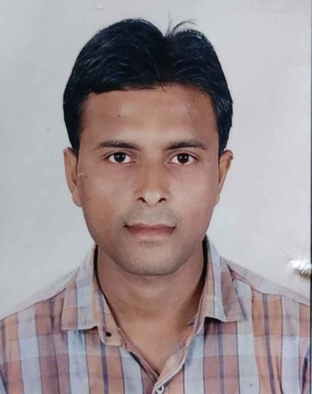

|  |  |
| --- | --- |
| **PERMANENT ADDRESS** |  |
| **Plot no: 85/A street No: 3 Amar Society Kumabharwada Bhavnagar- 364006**  **mobile:**  **(1) 8487070223** |
| **PERSONAL DETAILS:** |
|  |

.

* Date of Birth : 07/08/1990
* Gender : MALE
* Marital Status : UNMARRIED
* Nationality : INDIAN
* Language Known : GUJARATI HINDI, ENGLISH

**ACADEMIC QUALIFICATION:**

|  |  |  |  |
| --- | --- | --- | --- |
| **Name of degree** | **Years of passing** | **Board/uni** | **Percentage** |
| M.com | APR- 2018 | M.K.B.U | 57% |
| B.COM | DEC 2015 | M.K.B.U | 55% |
| c c c | JULY-2011 | ITI  BHAVNAGAR | 47% |
| H.S.C. | Mar-11 | G.S.E.B. | 55% |
| S.S.C. | Mar-09 | G.S.E.B. | 50% |

**INTEREST:**

* Reading, Music, Traveling**,**
* To meet knowledgeable and intelligent people so that I can learn something from them

**EXPERIENCE:**

* I have done job in Railway post office of Bhavnagar (RMS branch) As an “Assorting Assistant” For 3 Year.
* I have done job BAJAJ Allianz life insurance Aa an “SRM” For 1 Year 5 month.(06/12/2018 to 20/04/2020)
* Still now TATA AIA Life insurance As an “CAM” For 21/04/2020.(IB-BANCA)

**Career objectives**

I want continuous growth in my career and for that I am ready to do hard work, I will update my knowledge and I also come up with changing situations.

**Decalration**

I hereby declare that the information furnished here is true and in the area of my understanding.

Yours faithfully

Sumitkumar. M.Sarvaiya.