ASHISH APPUKUTTAN  ashish.appukuttan@gmail.com  8879063558 | “I am an IT professional with 17+ years of experience in various sectors like real-estate, retail and CRM.”
#Expertise:  + IT Infrastructure  + Backup & Disaster Recovery  + Security  + Vendor Management  + Inventory Management  + Database Management  + Application Support  #System exposure:  + Salesforce  + SharePoint  + MySQL  + VB.net  + Tableau  + SonicWALL  + GajShield  + NAS  + Google Apps  #Education & Professional Qualification:  + Graduate (Commerce) from Mumbai University  + Higher Diploma in Software Engineering from Aptech Computers  #Hobbies & Interests:  + Passionate about cars, technology and music. | Work Experience:  + Vijay Suraksha Realty LLP - IT-Manager  2011-MAY – present – (9 years)  - Was part of the core team as technical lead in implementing CRM on Salesforce. Also imparted training to users.  - Migrated on-premise email server to cloud on G-Suite. Handling administration of G-Suite Apps.  - Handled new office IT setup and shifting of infrastructure with zero downtime.  - Oversees the administration and maintenance of company's IT infrastructure.  - Keeping track of assets, licenses and AMC.  - Firewall management.  - Vendor management.  - Procurement and allocation of IT assets.  - Oversees data backups, archiving and disaster recovery plans.  + Planet M Retail Ltd - Dy. Manager-IT Infrastructure  2008-MAY to 2011-APR – (3 years)  - Handling complete IT infrastructure of corporate and regional offices.  - Procurement and allocation of IT assets.  - Monitor timely deployment of assets/services by the service provider.  - Managing existing MPLS VPN connectivity. Ensuring maximum uptime.  - Firewall management.  - Manage email accounts.  - Ensuring maximum network uptime and virus free network.  + Lakewood Malls Private Limited - Sr. Officer EDP  2005-DEC to 2008-APR – (2.5 years)  - Handling IT of three stores and head office.  - Database administration and fine-tuning.  - Resolving issues related to software bugs by coordinating with software support team.  - Procurement of new hardware/software as per the need.  - Configuration of email clients like MS Outlook and Outlook Express.  - Taking backups of data and emails.  - Updating new patches/versions on database/application/antivirus/OS.  - Creation of user accounts and assigning rights to them and managing them.  - MIS.  - Vendor management.  - Systems administration, Network trouble-shooting, System maintenance.  + Indian Market Research Bureau - System Executive  2001-SEP to 2005-NOV – (4.1 years)  - Administration of Mail-Server(MDaemon6). Monitoring the flow of emails.  - Configuration of email clients like MS Outlook and Outlook Express.  - Maintenance and fine-tuning of a master database.  - Taking backups of data and emails.  - Creation of user accounts and assigning rights to them and managing them.  - Development of applications as and when required.  - Generation of reports.  - Updating Antivirus software with latest updates & patches.  - Systems administration, Network trouble-shooting, system maintenance.  + Aptech Computers - Lab In-charge  2000-NOV to 2001-APR – (6 months)  - System Administration, Network trouble-shooting, system maintenance  - Responsible for maintaining a LAN of 40 systems.

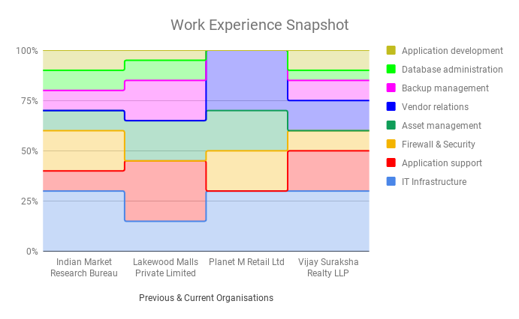
+ IT infrastructure is my core forte.
+ Learnt application development which helped in developing in-house applications like CRM for sales, auto-emailers, etc.
+ Application support includes training, troubleshooting, generating backend reports, data-visualisation, etc.
+ Handled various databases like FoxPro, Oracle, MS-SQL, MySQL and MariaDB.
+ Backup plan ensures business continuity by provisioning on-demand historic backup of databases and data-files.

