Curriculum Vitae

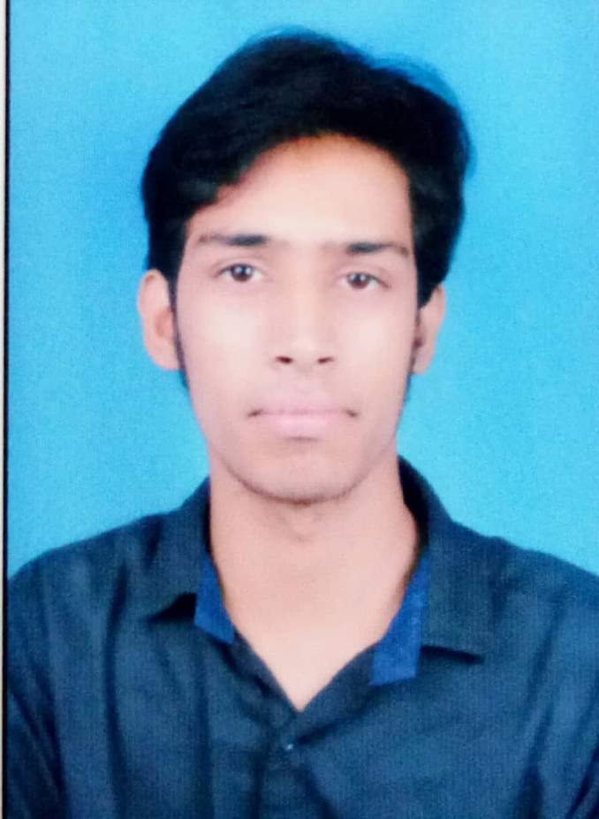

Career Objective:-
To make a position for myself in the competitive corporate world and contribute to achieving the goals on both professional and personal level.

Academic Chronicle:-
Studied B.E. (CSE) from OP Jindal Institute of Technology, Raigarh, Chhattisgarh.

Course | Institution | Board / University | Year of Completion | Grade / Percentage
BE | O.P Jindal Inst. of Technology | CSVTU | 2017 | 71
XII | Mona modern hr.sec school | CGBSE | 2013 | 78
X | Ashoka Public school | CGBSE | 2010 | 71

Technical Skills / Certifications:-
- Participated in zonal Robotryst -2014 from Robosapiens, Delhi seminar organised in our college.
- Participated in technorollix cultural activities -2014,15,16 in our college.
- Participated in HTML 5 three days workshop in 2014 by external guest.
Training:-
- 3 months Completed certification course in vocational training Core JAVA from CG Infotech, Raigarh in 2015.
- 3 months Completed certification course in Adv. JAVA from Durga Soft Solution, Hyderabad in 2016.

Minor Project (College Campus Projects) -.
- To design a application on “Online Notice Board System” using Android .
Major project Details:-
- To design a web based application “Online Job Portal” based on Php.

Experience -:
- 6 Months worked as a Office Management at Erickshaw Work Center, Raipur,CG.
- 6 months worked as a Software Developer at SJAIN Ventures in Raipur which is leading IT Company.
- 3 months worked as a SAP Basis Trainee at Geschaft Formulae India Pvt Ltd,Raipur(C.G.).
- 1 year SAP BASIS Consultant & Support at SARDA ENERGY & MINERALS Ltd, Raipur(CG) as well as completed 2 implementation projects which mentioned below -
Projects -:
I have done two projects -
- Worked as SAP BASIS Consultant on SAP S/4 HANA Implementation on SKS Ispat and Power Ltd at Raipur(CG).
- Worked as SAP BASIS Consultant on SAP S/4 HANA Implementation on SKS Power Generation Chhattisgarh Ltd at Raigarh(CG).
Awards and Recognitions:-
- Won a second position in fruit mania events in technorollix -15.
- Awarded the Entry Level Scholarship based on percentage in our college.

Area of Interest :-

- SAP BASIS Support
- SAP BASIS Implementation Project
- Software development, C,C++,Java,PHP
- Office Management

Personal Particulars:-
Name | : | Satyam sahu
Father’s Name | : | Mr.Sitaram Sahu
Mother’s Name | : | Mrs.Sushila Sahu
Permanent Address | : | At Post - Dansara, Teh- Sarangarh, Dist-Raigarh(CG), 496445
Date of Birth | : | 21 December 1994
Gender | : | Male
Nationality | : | Indian
Hobby | : | Socializing-community or volunteer work.  Computer,gardening,reading,writing,traveling  Sports -cricket,badminton,chase,carrom.
Language Facility | : | Hindi,English.

Declaration:-
I hereby declare, the information furnished above is complete and correct to the best of my knowledge.

Place: Raigarh Signature
Date: Satyam Sahu

