**AJAY KUMAR**

**E-Mail: ajayapi5566@gmail.com**

**Phone:- +91 7275630019** 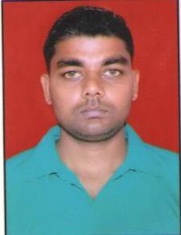

**Initial Level Assignments**

Goal-oriented professional with proven skills in **File Handling Management** with a leading organization of repute in **Real Estate**

**CAREER OBJECTIVE**

Seeking a strategic role in a dynamic organization of high repute, to contribute accrued skills in Fructifying tangible and strategic organizational objectives.

**WORK EXPERIENCE**

**Company**  **:** **Ansal API Infrastructure Limited.**

**(Sushant Golf City Lucknow.) UP.**

**Designation** **:** **Record Keeper**.

**Duration**  **:** **April 2014 to till date.**

**JOB RESPONSIBILITIES**

* Filling Maintenance charges bills of different sectors.
* Handling all the files related documents of the CRM department as well as of civil department electricity department, mechanical department.
* Maintaining the dispatch register and inward register.

**ACADEMIC DETAIL**

* Qualified P.G.D.C.A. from Shri Krishna Mahavidyalaya, Faizabad, UP in 2013.
* Qualified B.A. from MDU Rohtak, Haryana in 2005.
* Qualified Intermediate from B.O.S.E. Haryana in 2002.
* Qualified High School from B.O.S.E. Haryana in 2000.

**IT SKILLS**

* MS Office – Windows 2000 / XP /Windows 7 / VISTA/Outlook.
* Advance fundamental of computer literacy
* Good Knowledge of file maintenance software. (OPEN KM)

**HOBBIES**

* Listening Music
* Playing games (cricket, chess)

**PERSONAL DETAILS**

**NAME :** AJAY KUMAR

**DATE OF BIRTH :** 10th may 1985

**MOTHER`S NAME :** Smt. Nirmala devi

**FATHER`S NAME :** M r. Ram sabad yadav

**MARITAL STATUS :** Married

**LENGUAGES KNOWN :** English & Hindi

**PARMANENT ADDRESS :** Village –pure lala , post – katari ,

(khajurahat) , Bikapur ,Faizabad, UP.

Pin code – 224206

**DECLERATION**

I hereby declare that all the information furnished above is true to the best of my knowledge.

(AJAY KUMAR) Date :

Place :