**C.V**

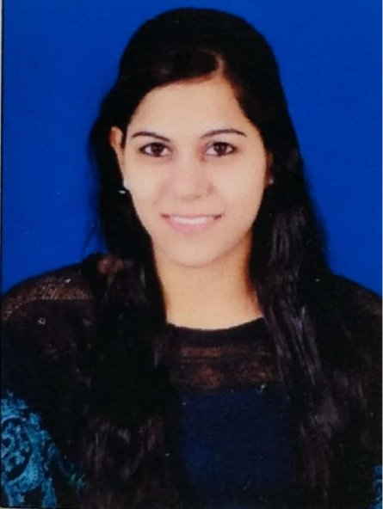

PREETI GYANSWARUP SANGWAN

**Correspondence Address:**

**Flat no. 107, Shivanish Paradise,**

**Gulmohar road, Near Mamta Gas Godown,**

**Parijat Chowk, Savedi,**

**Ahmednagar – 414003**

* preetigsangwan@gmail.com
* 9890741000

**CAREER OBJECTIVE :**

To be an integral part of growth oriented corporate team, which will provide better career opportunity to leverage my skill and experience to facilitated organizational growth and individual satisfaction.

**KEY SKILLS :**

Very enthusiastic, energetic, excellent written and verbal communication, strong presentation, negotiation and influencing skills. Relationship building skills, sales promotion, and an ability to handle team in the multicultural environment.

**LANGUAGE PROFICIENCY :**

English, Hindi and Marathi

STRENGTHS :

Leadership qualities

Target Oriented

Punctual

Soft Spoken

**WORK EXPERIENCE :**

|  |  |
| --- | --- |
| **Organization** | **FUTURE GENERALI LIFE INSURANCE CO. LTD.** |
| **Designation** | **Agency Organizer** |
| **Location** | Ahmednagar |
| **Responsibilities** | * Handling team work. * Growing business. * Field work and maintaining 100% targets achievement. * Control of daily lead flow & productivity as well as other activity. * Maintain good & quality portfolio. * Plan of action for day wise / week wise & finally month wise target achievement with team. * Achieve set goals in segments (Insurance). * Total Control of business. * Find out Potential Cases by tele calling. * Make them interested & take appointment for demonstration. * And also responsible for monthly sales. |
| **Reporting to** | Manager –Branch Manager |
| **Duration** | 09th Dec 2012 to 27th may 2014. |

|  |  |
| --- | --- |
| **Organization** | **INDIA INFOLINE FINANCE LTD.** |
| **Designation** | **Jr. Officer Gold Valuer** |
| **Place** | Ahmednagar |
| **Responsibilities** | * Managing CC Leads & Conversion ratio. * Appraise the gold. * Handling all cash transactions. * Finalize the value of gold for loan. * Disburses the loan against gold. * All operational work of gold loan. * Maintaining approval ratio & Control on daily rejection. * Maintain good & quality portfolio. * Achieve set goals in both segments (GL / Insurance). * Growing business for the branch. * Giving best offers or suggestions to customers regarding his GL. * Maintaining good relation with customers for future business potential. |
| **Reporting to** | Branch Manager – Gold Loan |
| **Duration** | 14th Aug 2014 to 2nd Jul 2015. |

|  |  |
| --- | --- |
| **Organization** | **YES BANK LTD.** |
| **Designation** | **Relationship Manager** |
| **Place** | Ahmednagar |
| **Responsibilities** | * Opening accounts of HNI customers * Provide best services * Maintain best relation with customers for future business * To find worthy customers and closing Life insurance. * Cross sell management * Maintaining approval ratio & Control on daily rejection. * Maintain good & quality portfolio. * Achieve set goals in All segments * Total Control of business. * All operational work of CTS Updation. * Giving best offers or suggestions to customers regarding there all requirements. |
| **Reporting to** | Branch Manager – yes bank ltd. |
| **Duration** | 22nd march 2017 to 1st June 2018 |

|  |  |
| --- | --- |
| **Organization** | **SINGAPORE GLOBAL INVESTMENT LTD.** |
| **Designation** | **Personal Secretary in India and Abroad** |
| **Place** | Singapore |
| **Responsibilities** | * Arrange international meetings with MD. * To corresponding with foreign associates. * Handling Indian office work over the phone. * Maintaining good relations with ministers and legal authorities of every country. |
| **Reporting to** | Chairman of SGIL Singapore |
| **Duration** | 14th June 2018 to 31st January 2020 |

**ACADEMIC BACKGROUND :**

|  |  |  |
| --- | --- | --- |
| **DEGREE** | **YEAR** | **PERFORMANCE** |
| Master in Business Administration (MBA) | 2016 | First class |
| Bachelor in Commerce (B.COM) | 2012 | First Class |
| Higher Secondary School (12th) | 2009 | Second Class |
| Secondary School Certificate (10th) | 2007 | First Class |

**PERSONAL INFORMATION :**

|  |  |
| --- | --- |
| DATE OF BIRTH | 29th Sept. 1991 |
| HOBBIES & INTERESTS | * Bike riding * Listening to Music |
| **MANAGERIAL COMPETENCIES** | * Ability to think and work innovatively * Ability to work collaboratively with others * Good time management skills * Ability to work under pressure |

**DECLARATION :**

**I hereby declare that the above mentioned information is correct and authentic to best of my knowledge.**

**Thanking you,**

**PREETI G. SANGWAN**

**Date :**

**Place : Ahmednagar**