*** CURRICULUM VIATE***

***Shole Sharma***

***Contact No – +91- 8726297180, +91- 8853012865***

***E-MAIL ID :- sholesharma80@gmail.com***

***OBJECTIVE:-***

***` To Work in a Challenging and Stimulation environment with Opportunities to Enrich***

***My Knowledge and to enhance my experience and skill, with help in Contributing to***

***The growth organization .***

***ACADEMIC QUALIFICATION:-***

***10+2 Passed from U.P Board in 2009.***

***High school Passed from U.P Board in 2006.***

***COMPUTER EXPERIENCE:-***

***One year Diploma in computer Application (H.D.C.A) .***

***Soft Ware Application M.S Office – Word , Excel , Power Point .***

***Operating System – Dos , Windows 2007 .***

***Tally – 7.2 & 9.0 Account & Inventory.***

***DTP – Page maker , Corel Draw 10, Photo shop 7 & 9.0 .***

***Html , Fox pro , C++ , Visual basic , Internet ETC .***

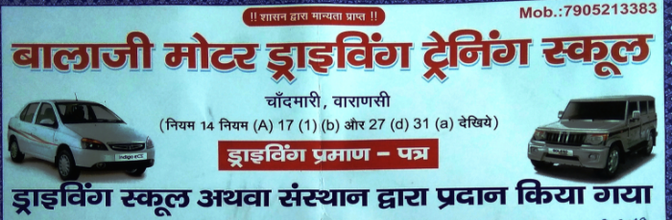***FOUR WHEELERS EXPERIENCE:-***

***WORKING EXPERINCE:-***

***Supervisor - I.G.I Airport Tristar Global Infrastructure (P) LTd. (GMR)***

***From New Delhi in One Year.***

***Computer Operator - Rahul Trading Co.(Waste Papers Supp.) From Varanasi In Six Year .***

***HOBBY :-***

***Reading books, Working with Computer, music.***

***JOB PROFILE :-***

***Handling wages and salary admistratiom distribution of salary .***

***Preparation of salary and bonus .***

***Mainting housekeeping & Securities Servies .***

***Data entry billing report make & input output of the material.***

***Sale & Purchase row material and discount .***

***STERNGHTS :-***

***Abel to Work better than Other in less time .***

***Helping Nature .***

***Confidence and Positive thinking .***

***PERSONAL DETAIL:-***

***Father name :- Mr. Kanhaiya Lal Vishwakarma***

***Marital status - :- Married***

***Language known :- Hindi & English***

***Nationality :- Indian***

***Date Of Birth :- 16-04-1990***

***Permanent Add :- Vill - Mahuar kala***

***Post - Mahuar kala***

***Dist - Chandauli (u.p)***

***Pin Code- 221115***

***DECLARATION :-***

***I hereby declare that all information provided above and particulars given***

***Are true to the best of my knowledge.***

***Date: - ………………………... Shole Sharma***

***Place: - …………………………***