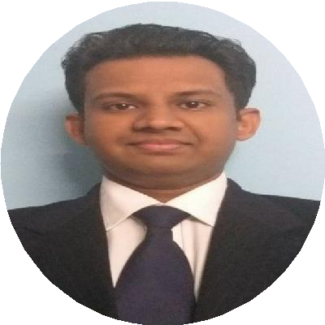

rohan.roy27929@gmail.com
Rohan Roy
A dynamic banker looking for higher responsibilities to demonstrate my potential.
8692094539
Andheri west, Mumbai, India
www.youth4work.com/y/rohanr oy

WORK EXPERIENCE

Risk Operations Analyst

Citibank N.A
05/2019 – Present Achievements/Tasks
Analyzing credit exceptions and understanding credit requirement
Preparing MIS for risk analysis
Suggesting changes in the credit limits to help reduce transaction volumes

Mumbai

linkedin.com/in/rohan-roy- 5b546998

SKILLS
Financial analysis

Identifying changes in the risk manual and ensure changes are incorporated in the process
Approving and performing due diligence on Lines of Credit extended to bank’s corporate clients headquartered across the globe.
Ensuring credit utilizations across all banking products are within the threshold and in adherence to both local and global regulatory requirements.
Perform reconciliations to analyze areas of credit excess and providing solutions to respective stakeholders to curtail possible credit breaches.

Retail Risk Processor- unsecured loans
Financial management

HDFC Bank on ADFC payroll
10/2015 – 09/2016
Credit analysis
Achievements/Tasks

Mumbai

Obtain and verify ﬁnancial information, such as the applicants credit rating and income level Analyze and evaluate the applicants ﬁnances to decide if the applicant should get the loan Approve loan applications or refer them to management for a decision
Team handling
Leadership skills

Phone banking oﬃcer
MS-oﬃce

HDFC Bank on ADFC payroll
10/2014 – 09/2015
Financial controlling
Achievements/Tasks
Won Best Employee- Customer Service and Quality from HDFC Bank.
Responsible for attending inbound calls and resolving customer queries related to their account, product or process related information.
MIS
Problem solving

Indore

Customer service,

LANGUAGES

Hindi
Native or Bilingual Proﬁciency

English
Native or Bilingual Proﬁciency
Ensure delivery of competent and consistent customer service, and meet the service standards.
Revenue generation through cross selling of the Banks products. Cross- selling of all Asset products, TPP products, Card products, Fixed Deposits and other liability products.

EDUCATION

MMS-Finance

University of Mumbai

07/2017 – 05/2019 Mumbaii

BMS-Finance

University of Mumbai
07/2011 – 06/2014

ACHIEVEMENTS

Event Head - Stock market trading in College festival (01/2018 – 01/2018) Won 1st prize in Management maestro event of the college in the year 2014

