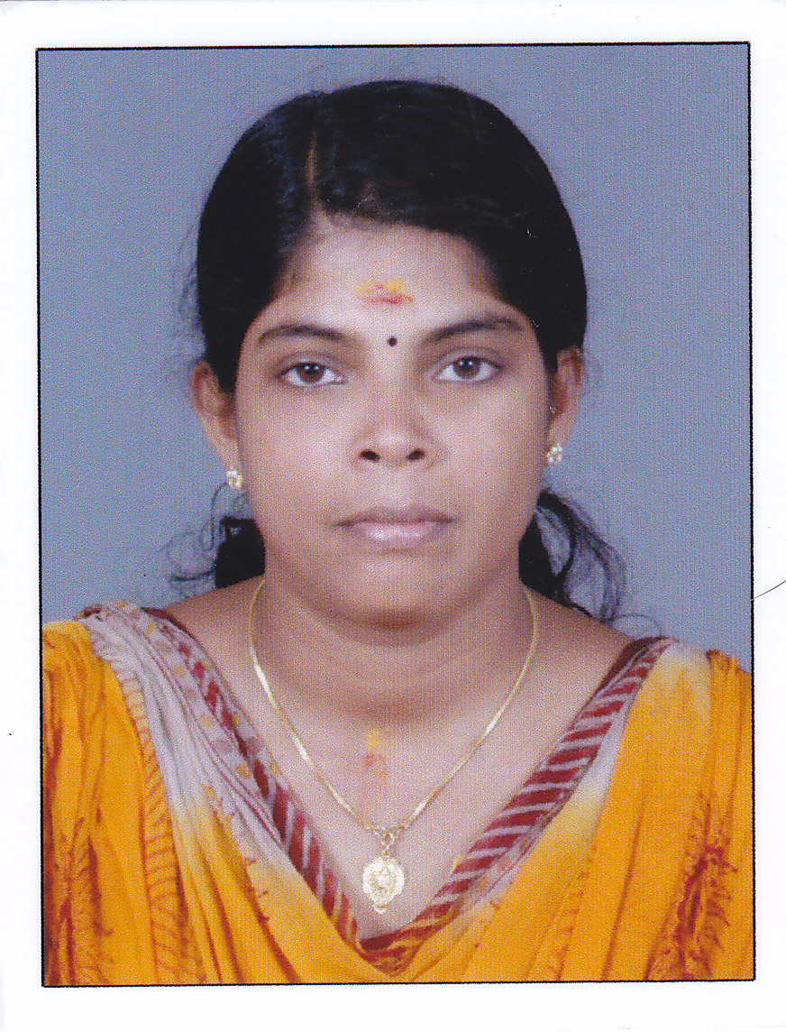
NISHA MURALI
Email ID – nishamurali2006@gmail.com
Contact No. +91 9946181573, +91 9447281841

Career Objective:

To pursue a challenging and growth-oriented career in an organization that offers opportunities to learn and grow by delivering the results.

Career Summary:

- A detail oriented with excellent knowledge of accounts possesses rich experience of 12 + years of experience in financial planning, analysis and accounting principles.
- Admirable capacity to improve and maximize overall business and finance function integration through effective communication processes.
- Experienced in keeping the records of daily financial transactions and analyzing the financial aspects of organization.
- Innovator with creative skills and experience to improve overall business processes.

Personality Traits:

- Strong analytical and problem-solving skills
- Highly trustworthy, discreet and ethical

Technical Skills:

- Well versed with MS office (MS Word, MS Excel)
- Experienced in working on Tally. ERP 9
- Internet Knowledge
- Knowledge of GST & TDS

Key responsibilities handled:

- Preparing and analyzing accounting records and financial statements reports
- To assess accuracy and conformance to reporting and procedural standards of the reports
- Compute taxes owed and prepare tax returns, ensuring compliance with payment, reporting and other tax requirements.
- Studying the reports given by auditors and submitting it to the Management
- Analyze business operations, trends, costs, revenues, financial commitments, and obligations, to project future revenues and expenses or to provide advice.
- Avoiding outstanding expenses and managing the petty cash
- Establishing table of accounts
- Assigning entries to proper accounts
- Preparing periodic reports to compare budgeted costs to actual costs.
- Using accounting tools wherever necessary
- Handling ledger accounts and keeping the check for any invoices or payments
- Making use of technology to develop, implement, modify, and document recordkeeping and accounting systems
- Preparing forms and manuals for accounting and bookkeeping personnel
- Survey operations to ascertain accounting needs
- To recommend, develop, and maintain solutions to financial problems of the business
- Work as Internal & external revenue service agents.
- Taking care of resource utilization, tax strategies underlying budget forecasts and suggest management the solution
- Provide internal and external auditing services
- Advise clients in areas such as compensation, employee health care benefits, the design of accounting and data processing systems, etc.
- Valuation of company assets and liabilities
- Maintaining and examining the records of government agencies.
- Serve as business valuators

Achievements:

- Surpassed set target and exceeded management expectation, thus recognized by the company management.
- Engineered amazing financial turnaround of the business unit deploying strategic plans and financial system improvement initiatives as well as implementation of control measures.
- Successful in independently handling accounts of the company up to finalization.

Employers:

- Working as Manager for GLH India Travel, Cochin from May 2017 – till date
- Worked as an Accountant for Dravidian Trails Holidays Pvt. Ltd, Cochin from Nov 2009 to April 2017
- Worked as Administrator & Coordinator – Special Events & Inbound Tours for GLH India Travel, Cochin from May 2009 to March 2010
- Worked as an Accountant for Deva Hospitality Pvt. Ltd, Cochin during September 2006 to April 2009
- Worked as an Accountant for Clarion Systems Pvt. Ltd, Cochin during August 2005 to August 2006
- Worked as a Junior Accountant for Standard Crockeries Pvt. Ltd, Cochin during April 2001 to August 2005

Academia:

- MBA(Finance) Degree from Pondicherry University
- M.Com (Finance) Degree from Mahatma Gandhi University
- B. Com Degree from Mahatma Gandhi University
- VHSE from St. Ignatius V.H.S Board
- SSLC from S Board

Personal Details:

- Languages Known: Malayalam, English, Tamil, Hindi

- Address: B4, Megha Apartment, Near Chottanikkara Temple, Chottanikkara,682312

- Hobbies: Reading, Travelling, and Listening Music

