RESUME
E-Mail | harishkr_dv@rediffmail.com
0096879346287
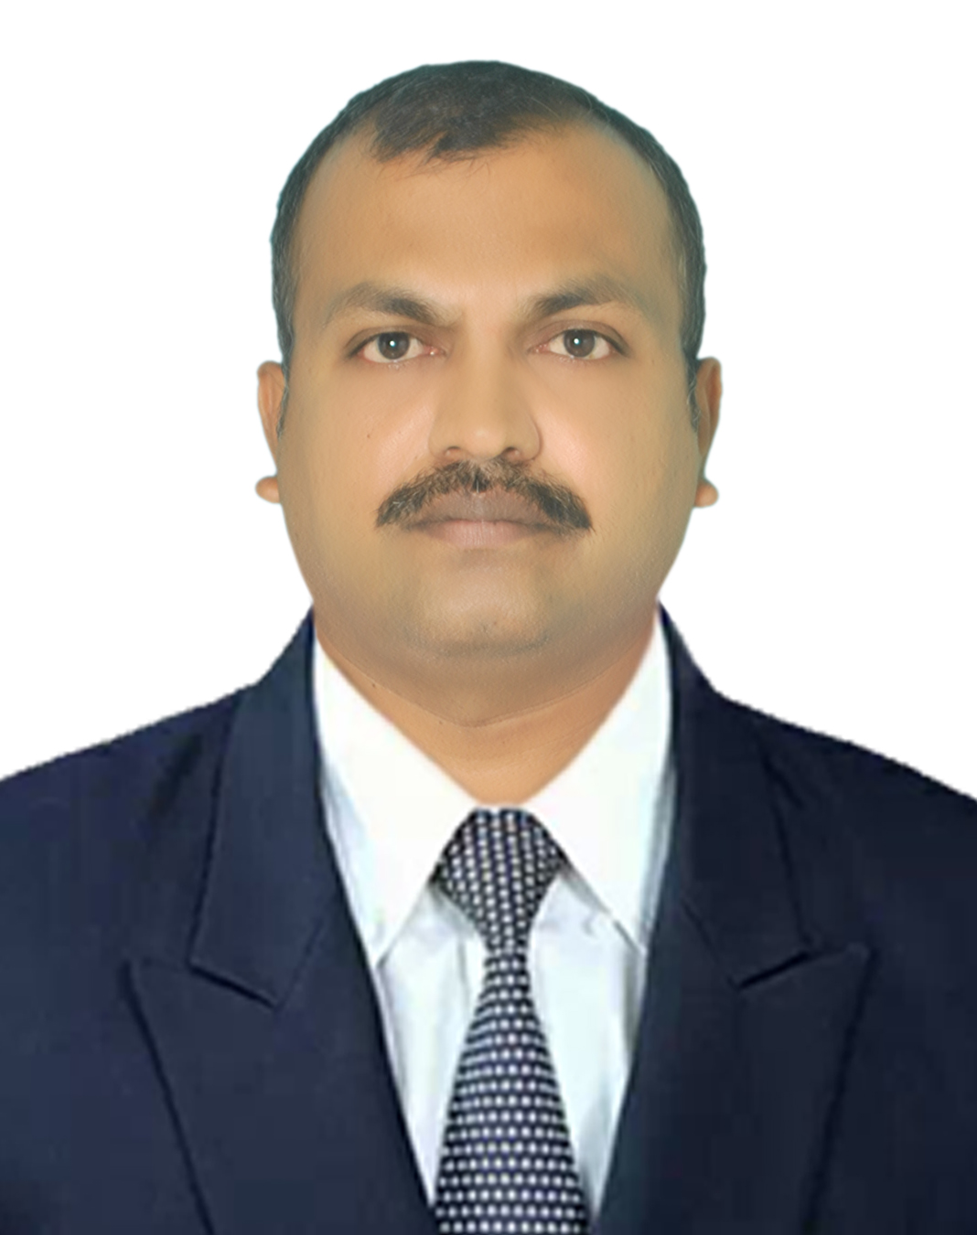

HARISH KUMAR. D.V.

Objective
Career orientation in a technical direction aimed at deliver optimal solutions to address customer requirements, harnessing and developing technical skills to deliver best of breed applications.

Summary
- 22years of experience in Aluminium Facade Project Management.
- 17 years of Gulf experience possessing excellence in all kind of projects like High Rise Towers, Villas, Govt Buildings and Airports.
- Possessing both Architectural Steel façade and Aluminium façade experience in various landmark projects in UAE and currently working at Oman.
Qualification
- B.E (Mechanical Engineering) from Kuvempu University, (Karnataka) Passed in first class. With distinction, in Nov 2000.
- M.B.A (Operation Research) from IGNOU, India passed in first class, in Oct 2005.
- PQP- Certification from ESTIDAMA for PBRS (Pearl Building Rating System). With 85%.

Professional Experience:

Currently working as Projects Manager at Dubai Metal Industries- DUBAI, UAE from Dec- 2018 to till date , handling Oman Museum Ages Across project – Nizwa- OMAN with SPOS ( OSCO & SPML) –JV as main contractor.

Summary of Job Responsibility:
- Planning and executing the works by leading the team with proper targets, plans and activity control at each stage.
- Interacting with Main contractor / consultants for solving site issues through regular site meetings and monitor the project activities closely to achieve the target on timely basis.
- Following up of payments in order to control the project under allocated budget.

Previous Employees Summary:
- Worked as Projects Manager at LEADER METAL INDUSTRIES- belongs to JUM – AL – MAJID GROUPS – DUBAI, UAE from June- 2015 to Nov 2018.
- Worked as Projects Manager at White Aluminium Establishment, Abu Dhabi, and White Aluminium UAE from Feb 2011 to June 2015.
- Worked as a Sr.Project Manager at Unique Diamond Aluminium and Glass Companies, co. Abu Dhabi, UAE from Nov 2009 to Jan 2011.
- Worked as a Project Manager at Eurocon Metal Industries, co. Ajman, UAE from Oct 2007 to Oct 2009.
- Worked as a Project Engineer at ETA Melco Elevator Co L.L.C (Product Division), Dubai. From July 2005 – Sept 2007.
- Worked as a Project Engineer at Alupro Building Systems, Bangalore, India. From Dec 2000 – June 2005.

The main projects handled are :
- Abu Dhabi- Airport MTB project with TCA JV as maincontractor- handled Architectural package with various steel items.
- DUBAI AIRPORT TERMINAL-1 ... 3 projects
BHS- Enclosure, SP500- 229, SP500 PK-14 and PK-30 involving Aluminium Cladding, Curtain wall (Guttmann System), Aluminium Louvers and Aluminium doors and windows. Around 4000 Sq mt cladding and 2500 Sq mt Glazing works.
- Mussel Eid Tower: G+15 Floor building with curtain wall (Technal System) 8500 sq m and cladding (Ajeco Bond) 6000 sq m.
- Zakheer police station, Prestigious Al Ain govt project which consists of 9000 sq mt of curtain wall (Technal System) and aluminium works.
- Social Support Centre, Social welfare ministry project consists of 3500 sq m of curtain wall (Technal system) and 8000 sq m of cladding (Alubond).
- Al Muhairi residential building with G +23 floors with 17500 sq mt curtain wall (AREXCO System) and 9600 sq mt cladding (Ajeco Bond).
- AL raha garden villas total 136 nos at Abu Dhabi , All windows, Doors ( Profils System ) and pergola
- ADNOC- RUWEZ HOUSING COMPLEX PACKAGE-12, RUWEZ, UAE. 8 residential towers G+ 11 floors for ADNOC staff accommodation involving aluminium windows and doors (Elite System) installation.
- Unique Diamond Aluminum and Glass Company. LLC, Abu Dhabi.
The main projects handled are:
- Yacht club in Formula 1 at Abu Dhabi. Cladding qty is 2000 Sq m (Alpolic )
- ‘D’ Tower in REEMI Island, Abu Dhabi. Qty is 24000 sq m (Ajecobond)
- Silver wave tower, Abu Dhabi. Qty is 15000 sq m (Alubond)
- Yaquob tower, Abu Dhabi. Qty is 9000 sq m (Alubond)
- Eurocon Metal Industries LLC, UAE.
Some of the important executed Projects’ List
- Residential Building at Al Barsha, Naresco. Cladding 9000 sq m (Alubond).
- Residential Building at Al Nadha, Omiz Cont. Cladding 7500sq m(Alubond)
- Public Library at Burdubai, Municipality Project. Cladding 3000sq (Alubond)
- Residential building at Karama, Al Arief Cont, Cladding 3500 sq (Alubond)
- Residential Bldg at Al Nadha, Al Oroba Cont, Cldg 9500sqm.(alubond)
- Residential Bldg at Al Nadha, JSCOM, 4500 sq m(Alubond)
- Danet Hotel, Abu Dhabi, Al Qudra properties, 8500 sq m.(Alubond)
- Residential Bldg, Naresco, 7500 sq m. (Alubond)
- Dubiotech Laboratory, Al Rawda, 3750 sq m(Alubond)
- ETA Melco Elevator Co.LLC, (Product Division), Dubai
Worked as a Project Engineer in ALUCOBOND Cladding Division.
PROJECTS EXECUTED:
- Marina Mall Extension - Total area cladode 4,800 sq mtr
ALUCOBOND
- Marina Tower - Total area cladded 4,900 sq mtr
ALUCOBOND
- Bel Ghilem Tower - Area 7,800sq mtr ALUCOBOND
- Saif Residential Tower - Area 2,600sq mtr ALUCOBOND

- ALUPRO Building Systems Pvt. Ltd Bangalore

PROJECTS EXECUTED:
- ST MICRO ELECTRONICS, Noida -India.
- Project consists of Structural Glazing 6500 sq mtr, ACP Cladding - 3,500 sq mtr make usedALCOPLA and German Moudine tiles cladding 1500 sq mtrs.
- ING VYSA BANK, Bangalore -India.
Project consists of Structural Glazing 2500 sq mtr ACP Cladding 4,800 sq mtr make used ALCOPLA.
- MANTRI APPARTMENTS, Bangalore-India.
Project consists of Aluminium windows, doors, louvers of 8500 sq mtrs and ACP Cladding 1,800 sq mtr make used ALCOPLA.

PERSONAL DATA:
Date of Birth : 02 July 1978

Marital status : Married

Languages Known : Kannada, English & Hindi.

Permanent Address : #748, Hombelaku, Ashok Nagar main road,
Shivamoga - 577205 Karnataka, India.

Driving License : Valid OMAN License

