CURRICULAM VITAE
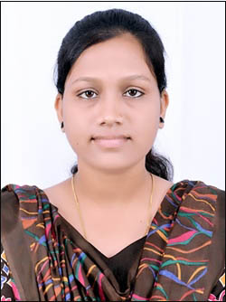
SANGEETA VEDBYAS
Email id-sangeetavedvyas13@gmail.com
Contact no- 9826913666

CAREER OBJECTIVES

A Highly motivated person, fast learner with good analytical and creative skills. Currently looking for a Challenging and Interesting environment to utilizing my abilities, developed through my educational qualification with an opportunity for career growth based on my merits & to promote organizations. I am seeking a position to expose myself to new Technologies and to be an Asset to the company.

VOCATIONAL TRAINING

MINOR- BHILAI STEEL PLANT (C.G)
MAJOR- WAGON WORKSHOP SHOP REPAIR RAILWAY BILASPUR (C.G)

EDUCATIONAL QUALIFICATION

TECHNICAL:

Degree in MECHNICAL ENGINEERING from CSVTU, BHILAI With 68 % in 2016
Institute – Govt. engineering college bilaspur (C.G.)

ACADEMIC:

Examination | Board/University | Year | Percentage
DEGREE | CSVTU BHILAI | 2016 | 68%
12TH | CGBSE RAIPUR | 2012 | 70.5%
10TH | CGBSE RAIPUR | 2010 | 82%
PROJECT

MAJOR PROJECT- VERTICAL J SHEP WIND TURBINE

PERSONALITY

Confident, Innovative, Energetic,
Hardworking, with Right attitude,
Positive attitude.

HOBBYS
Singing, dancing
Listen classical & pop music.

PERSONAL PROFILE

- Father’s name : Shri. Ramsewak vedbyas
- Mother’s name : Smt. Gayatri vedbyas
- Date of birth : 13-02-1994
- Nationality : Indian
- Religion : Hindu
- Gender : Female
- Marital status : Unmarried
- Category : ST
- Language : Hindi & English
- Permanent add. : Vill.-Surdongar, Street-Bazaar para, Post-Keska,l dist- Kondagaon
Pin-494331 (c.g.)
Current add. : Gandhi chowk, bilaspur, (c.g.)

DECLARATION

I hereby declare that the above mentioned information is correct up to my knowledge and I bear the responsibility for correctness of the above-mentioned particulars.

Place: ………….…

.Date: ………………. (SANGEETA VEDBYAS)

