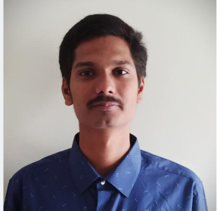

CHINMAY KULKARNI

ELECTRONIC &

TELECOMMUNICATION ENGINEER

CAREER GOALS

To work in challenging environment that provides generous opportunities for learning & advancement in my career.

PROGRAMMING LANGUAGES

PYTHON

FLUTTER+DART

LANGUAGE PROFICIENCY

ENGLISH(Conversational)

HINDI(Fluent)

MARATHI(Fluent)

SOCIAL ACTIVITIE'S

NGO

Anmol Art Foundation is Non governmental organization. AAF is successfully working to spread the art in categories like drawing/painting, Dance and also educational field.bheading

REACH ME AT

7719891409



chinmaykulkarni0701@gmail.com


www.suchvision.com


ACADEMIC HISTORY

GRADUATION

G H RAISONI COLLEGE OF ENGINEERING

Bachelor of Electronic & Telecommunication Rashtrasant Tukadoji Maharaj Nagpur University Currently Pursuing (7.93 CGPA)

XII

ST.PAUL JUNIOR & SENIOR COLLEGE

Graduated Class of 2017

State Board

First Class

X

R.S.MUNDLE ENGLISH SCHOOL

Passed out 2015

State Board

Distinction

PROJECTS

1.FACE RECOGNITION USING OPENCV IN PYTHON

Face recognition systems use computer algorithms to pick out specific, distinctive details about a person’s face.
These details, such as distance between the eyes or shape of the chin, are then converted into a mathematical representation and compared to data on other faces collected in a face recognition database.

2.CELL PHONE DETECTOR(CPD)

Cell Phone Detector(CPD) will detect the hidden cell phones.
Which will be used in Examination Hall's to detect the student caring Cell Phone.

CERTIFICATE'S

1.ANDROID DEVELOPING

Study of Android Development Applications like game ,video applications.

2.BLENDER

Blender is the course where I learned Game Designing.

3.BITCOIN TRADING

V-73,Vijayanand Society Sai-Suman | Bitcoin has the largest market capitalization by far of
Appt. Narendra Nagar Nagpur | Bitcoin has the largest market capitalization by far of
Appt. Narendra Nagar Nagpur | all cryptocurrencies, 19 times larger than the runner up Ethereum.
440015

