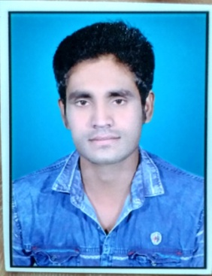

Mo - 9584707606

Email -- [dharmendrachandravanshi007@gmail.com](mailto:dharmendrachandravanshi007@gmail.com) Add. – gupta Ram nagar kawardha, chhattisgarh

|  |
| --- |
| **PERSONAL INFORMATION** |

**Date of birth : 05 / 07 /1997 place of birth : Ramhepur(khurd) ,raveli**

**Age : 24 year old Gender : Male**

**Marital status : Single Nationality : Indian**

|  |
| --- |
| **QUALIFICATION** |

* **2016-2017 ITI with Computer operator and programming assistant**
* **2020-2021 BSC in microbiology**
* **2014-2015 12th in Science (Biology)**

|  |
| --- |
| **SKILL AND STRENGHTS** |

**Computer Literate Microsoft office**

**Microsoft excel**

**Language Hindi, English, Chhattisgarhi,**

**Experience. - 5 year office managment and computer operating truck association**

Can work under pressure to meet tight deadlines independent and self motivated.