### **INDUSTRIAL TRAINING/PROJECTS**

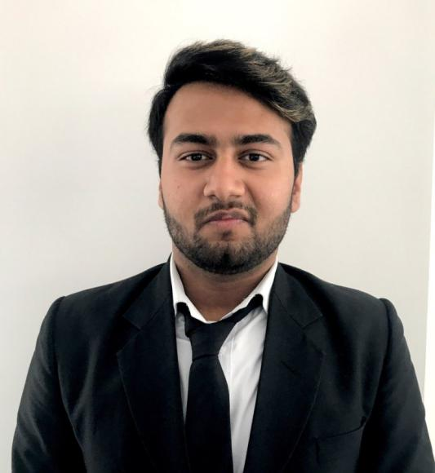

# **raghav saini**

Master of business administration

# **Objective**

1. To learn and gain the experience of working for an organization and be able to upgrade my skills.

## **Skills**

* Basic knowledge of MS Word and MS Power Point
* Basic knowledge of Excel
* Leadership skills

## **Vitals**

1. c Wazir Nagar Kotla Mubarak Pur New Delhi New Delhi 11000

Contact No. (+91)-8178728505

Email- raghavsaini15@yahoo.com

* Two months Summer Internship in Genex Life Science Pvt. Ltd.(June-August) 2016.
* Two months management intern in New Delhi Institute of management 2017.
* One month virtual internship in youth4work.com (July) 2018 in the field of content marketing.
* One month & 15 days summer internship in AASHLOK FORTIS (May – June ) 2019.
* Project report - Human Resource Management At GENEX LIFE SCIENCE PVT. LIMITED .
* Project report – Winding Up Of Human Resources At AASHLOK FORTIS, Delhi.

### **Education**

* Pursuing MBA from Periyar Management and Computer College , New Delhi (GGSIPU), 2018-2020.
* B.B.A from NDIM College, New Delhi (GGSIP University), 2014-2017.
* Senior Secondary from GURU HARKRISHAN PUBLIC SCHOOL CBSE board ,2014.
* Secondary from VIDYA PUBLIC SCHOOL CBSE board, 2012.

### **extra curricular activities**

#### Participate inter college dance show,2016.

#### Organized cultural and social events in NDIM, 2017.

##### organized cultural and social events in pmcc , 2018 & 2019.

### **AchiEvements**

#### Gold medal in fine arts,2017.

### Gold medal in fashion show and social welfare activites,2016.

### Trophy for “Shikshit Bharat Abhiyan”,2016.

#### Invited as a “Judge” of cultural event - Manthan, 2018 for “DJ WAR” at NDIM .

##### Invited as a “Judge” of cultural event - Manthan 2019 for “BATTLE OF BANDS” at NDIM.

* Appointed as “Mentor” for Fashion Show, 2018 & 2019 at NDIM.
* Received certificate of mentoring fine arts at NDIM in 2019.
* Appointed as a “Mentor” for Fashion Show, 2019 at PMCC.
* Appointed as a “Choreographer “ for “ MR & MISS INDIA” ,2019 at Delhi Audition by “CEBO PRODUCTION HOUSE”.
* Invited as a “Judge” for fashion show at “FASCINO FACES”.
* Invited as a “Judge” for designer meet at” FASHION RUNWAY” 2019.
* Invited as a “Judge” for “ZERONE MR & MISS INDIA”, 2019 at Delhi audition .
* Received a letter of appreciation from “LAKME”.

**Strengths**

#### Positive attitude

#### confident

* Self motivated
* Initiator