**Personal data**

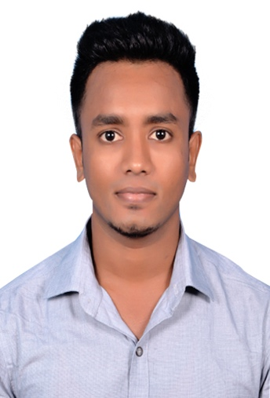**Name** Sarathkumar

**Last name** J. Rajan

**Address** No 9, Bharathi Apartment, Flat no 3, Abusali Street,

Saligramam, Chennai - 93

**Mobile** +91 8072336217

**E-mail** [capesarath@gmail.com](mailto:capesarath@gmail.com)

**Date of birth** 24 August 1993

# Academic Qualifications

|  |  |  |  |  |
| --- | --- | --- | --- | --- |
| ***Course*** | ***University/Board*** | ***Institute*** | ***Year of*** | ***Percentage / CGPA*** |
| ***passing*** |  |
|  |  |  |
|  |  |  |  |  |
| *S.S.L.C* | *State Board* | *Thirthapathi Hr Sec* | *2009* | *89* |
| *School* |
|  |  |  |  |
|  |  |  |  |  |
| *H.S.C* | *State Board* | *Thirthapathi Hr Sec* | *2011* | *80* |
| *School* |
|  |  |  |  |
|  |  |  |  |  |
| *B.E Mechanical* | *Anna University* | *Cape Institute of* | *2015* | *83.4* |
| *Engineering* | *Technology* |
|  |  |  |
|  |  |  |  |  |

# Work experience

**06/2015 – 02/2017** **Quality / Production Engineer**

**Hyundai Motors, Chennai.**

**Quality area**

* Determining quality improvement parameters by using various tools and to ensure quality of products.
* Visual inspection of goods and clearance to the finished good components and final inspection report preparation with collected data.

**Production area**

* Implementation of various techniques and quality standards like 5S for improving operations along with cost savings with respect to various functional aspects.
* Production log & in-housework plan preparation and advance delivery planning based on the customer requirements. Monthly audits for materials.

**03/2017 – 05/2018** **Operation Executive.**

**HighpowerV Media Entertainment & Communication Pvt.**

**Administrative tasks**

* Office administration maintenance and client management for business development.
* Covering different scenarios to get the job done.
* Exceptional leadership and team building qualities.
* Controlling of logistics movement from goods in-bound to shipping.

**Nature of work**

* Lead & Direct a forward-thinking team for professionals, varying from operations teams, admin team in Chennai, Bangalore, Delhi & Mumbai branches of the company.
* Plan and carry out the region’s year plan stating the growth of the company in terms of revenue generation, executing the various promotions & events, coordinating with the business development team, meeting the targets given for the region & coordinating with multiple cities for executions.
* Project handled include BYJUS learning app for which around 1000+ schools were covered in a span of 10 months and sales deployment program for Samsung India Pvt Ltd.

**06/2018 – 04/2020 Goodwin Advertisement Pvt Ltd.**

***Jet Airways - Promote Intermiles (Jet Privilege loyalty program)***

* Train executives about Jet Privilege loyalty program.
* Trained executives will be given a brief training both in theoretical and practical areas to the Indian Oil Corporation petrol pump attendees.
* Sending report on all activities on a daily basis.
* Monitor the program, number of trainings and Jet privilege number.

# Languages and computer skills

**Fluent**  Malayalam, Tamil, English

**Professional Experience** Microsoft office, Auto CAD, MS-Outlook

# Hobbies and interests

* Have submitted around 6 different papers covering topics from chemicals to renewable energy sources.
* Won various prizes for being athletically active since school.
* Attended and coordinated various workshops and conferences on college basis.
* Hobbies include reading books, travel, podcasts and cricket.
* Attended various workshops in topics like composite materials, engineering optimization and renewables.
* Active seeker of mindful living through various body building practices.

*CAREER OBJECTIVE*

To attain excellence in the professional world by gaining experience and exposure and help the company grow in whatever way I can through hard work and determination.

I hereby declare that all the details furnished here are true to the best of my knowledge.

Chennai, 11.11.2020 Sarathkumar Rajan