CURRICULUM VITAE
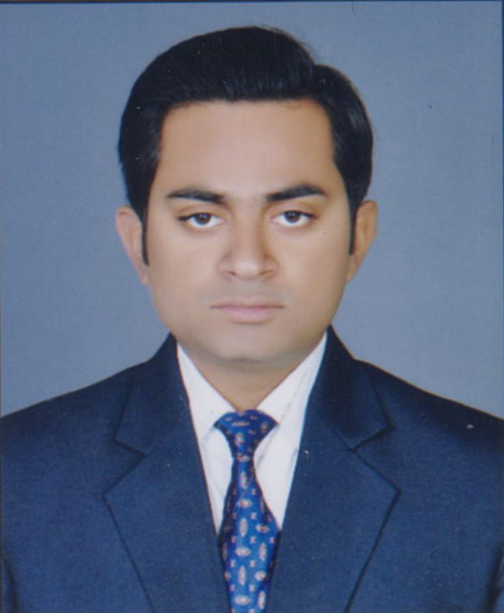
MOHD NASEEM
Mobile No: 7905035316
E-mail ID: naseemmba786@gmail.com

Experience History :-
- 8 Months of Experience in Indusind Marketing and Financial Services Pvt. Ltd. (Indusind Bank) as a Relationship Officer in Secured Asset Mortgages Loans LAP Dept. in Lucknow. (May 2019 to December 2019).

- 1 Year 7 Months of Experience in Axis Securities Ltd (Axis Bank) a Retail Asset Loan Dept (Mortgages) of Axis Bank Ltd, Lucknow as a Relationship Officer (Sales) in Working Capital (Small Business Banking Group) Dept. (June 2016 to December 2017).

- 1 Year of Work Experience in HDFC BANK LTD, Lucknow as a Sales Executive on the Payroll of HBL Global Pvt Ltd, in Working Capital (Emerging Enterprises Group) Mortgages Dept. (July 2015 to June 2016).

Roles & Responsibilities in Indusind Bank : - (May 2019 to December 2019).
- Lead generation and conversion of Secured Asset Mortgages Loans LAP files through Mapped branches of Indusind Bank.
- Working and converting leads through Portfolio of existing customers of Bank.
- Customer Relationship Management through CRM Next.
- Login and Sanctioning of Working Capital Loan Files.
- Disbursement of Files and Legal formalities of Customers.
- Closing and Finalising the lead through CRM Next.

Roles & Responsibilities in Axis Securities Ltd (Axis Bank) : - (June 2016 to December 2017).
- Lead generation and conversion of Working Capital Loan files through Mapped branches of Axis Bank.
- Working and converting leads through Portfolio of existing customers of Bank.
- Customer Relationship Management through CRM Next.
- Login and Sanctioning of Working Capital Loan Files.
- Disbursement of Files and Legal formalities of Customers.
- Closing and Finalising the lead through CRM Next.

Roles & Responsibilities in HDFC Bank : - (July 2015 to June 2016)
- Lead generation and conversion of Working Capital Loan files through Mapped branches of HDFC Bank.
- Working and converting leads through Portfolio of existing customers of Bank.
- Customer Relationship Management through CRM Next.
- Login and Sanctioning of Working Capital Loan Files.
- Disbursement of Files and Legal formalities of Customers.
- Closing and Finalising the lead through CRM Next.

Academic Qualification
Degree | Board/University | School/College | Branch/  Specialisation | Year of Passing | Percentage
MBA | Babu Banarasi Das University | School Of Management | Marketing(Major)  Finance (Minor) | 2014 | 72
BBA | Integral University | School Of Management | BBA (E-Business Management) | 2011 | 71.71
Class 12th | CBSE | Central Academy School | Science | 2008 | 64
Class 10th | CBSE | Central Academy School | Science | 2006 | 61

Professional Qualification : -

3 Months duration course PCLM (Professional Certificate in Logistics and Supply Chain Management from Safeducate Learning Pvt Ltd (Safexpress Logistics Pvt Ltd).
- Logistics Management, Supply Chain Management, Warehouse Management, Inventory Management, E-Commerce etc.
- Advance MS Excel.
- Export – Import
- Industrial Visit at Safexpress Logistics Pvt Ltd Hub Lucknow

Technical Proficiency and Certifications : -
- Certified Course of DOEACC ‘O’ Level (IT Applications) from DOEACC Society, New Delhi.
- Good knowledge of MS-Office, Advance Excel.

Achievements
- Rewarded as Star Award for Best Performance in Axis Bank.
- Got the Certificate in IT Euphoria 2010 (IT Fest) which was held in UPTEC Computer Consultancy Ltd, Lucknow.
- Core Committee member in UTKARSH 2013 (a management fest) & got Certificate which was held in Babu Banarasi Das University, Lucknow.

- Certified training course from Tata Consultancy Services ION Digital Learning (Knockdown the Lockdown) on different topics of Organizational Skills.

Strength :-
Management :-
- Extremely detail oriented with good analytical skills.
- Willingness to achieve tight deadlines by working hard.
Communication : -

- Fluent in English and Hindi.

Leadership : -

- Capability to create professional and safe work environment.
- Quick Learner and Team Player.

Skills

. Attended in campus Ranstad skill Training programme for Management and Industrial Readiness Initiative Training (IRI) by Reliance During MBA Curriculum.

. Good Communication Skills

. Positive Attitude

. Creative and workoholic

. Active Listener.

- Certified training course from Tata Consultancy Services ION Digital Learning (Knockdown the Lockdown) on different topics of Organizational Skills.
Personal Profile
Name  Father Name  Mother Name | MOHD NASEEM  MOHD FAREED  KHURSHEEDA
Address | 4/740 Vikas Nagar, Lucknow, 226022, Uttar Pradesh, India
Date Of Birth | 14 September 1991
E-mail ID | naseemmba786@gmail.com, mohdnaseem285@gmail.com
Hobbies | . Playing Cricket and Volley Ball  . Listening Music

Declaration:
I hereby declare that the above-mentioned information is correct up to my knowledge and I bear the responsibility for the correctness of the above-mentioned particulars.

Place: Lucknow, UP Mohd Naseem

