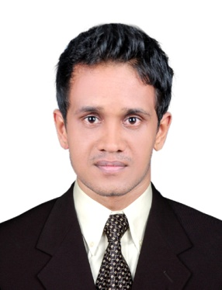**JOEL CHANDY**

Chandy House

Main Road

Kuriachira P.O

Thrissur - 680006

Mob: +91 9895055859

Email: joelchandy@gmail.com

**CAREER OBJECTIVE**

To be an asset of the company, where I can put my effort and skills to the best of my abilities and contribute for the welfare and success.

**EDUCATIONAL QUALIFICATION**

* MBA Marketing from Acharya Bangalore B-School of Management
* C.M.J university meghalaya (b.com)
* Higher Secondary Education, from Model Boy’s HSS Thrissur, Kerala
* SSLC ( Model Boy’s HSS Thrissur, Kerala

**EXPERIENCE**

2.8 Years experience in sales & marketing

**Job profile**

**Felicitating sale coordinator (ape sales)**

* Three wheeler piaggio ape cargo and passenger.

Four wheeler cargo “potter”.

* Sales officer at **AXIS BANK** Thrissur

**COMPUTER KNOWLEDGE**

* Tally
* ERP9

**PERSONAL DETAILS**

Father’s Name : Joseph Raphael

Date of Birth : 19-10-1990

Gender : Male

Marital Status : Single

Nationality : India

Religion : Christian

Caste : RC

Native Place : Kuriachira, Thrissur, Kerala.

**LANGUAGES**

English, Malayalam.

**STRENGTHS**

* Positive Attitude
* Hard Working
* Good Communication Skill
* Helping Mentality
* Ability to Work as individual as well as in group.
* Motivational and leadership skills.

**DECLARATION**

I do hereby declare that all the information given above is true to the best of my knowledge and belief. I also assure complete dedication and handwork towards the organization if an opportunity is provided.

Place: Thrissur

**JOEL CHANDY**