

**Taruna Pal**

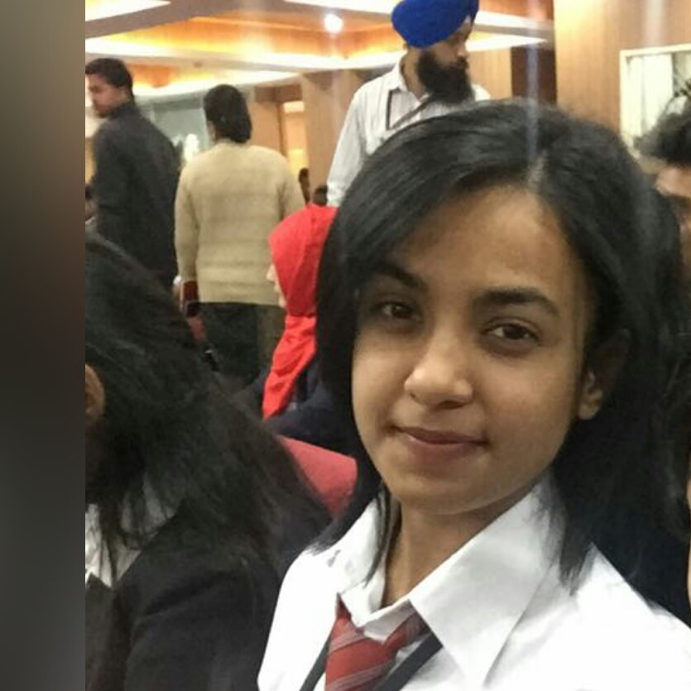

102, LIG flats, Vikas Puri

New Dehi, 110059

+91-9872345067

[tarunapal98@gmail.com](mailto:tarunapal98@gmail.com)

**CAREER OBJECTIVE:**

To work for an organization which provides me the opportunity to improve my skills and knowledge to grow along with the organization objective.

**ACADEMIC QUALIFICATIONS**

|  |  |  |  |
| --- | --- | --- | --- |
| **S.No** | **Institute name** | **Degree** | **Percentage** |
| 1 | Chandigarh University | B.E CSE(Hons.) | 68 % |
| 2 | Kamal Public School, New Delhi | Intermediate | 60.8 % |
| 3 | Kamal Public School, New Delhi | Mariculation | 74 % |

**KEY COMPETENCIES**

|  |  |  |
| --- | --- | --- |
| **Operating System** | **:** | Windows |
| **Language** | **:** | C++, Basics of Java |
| **Others** | **:** | Computer Networking**,** hadoop**,** operating system**,** content writing, Cloud computing |

**PROJECTS**

* **Project**: Network monitoring system using CISCO PACKET TRACER

**Duration**: One Month  
**Operating system**: Windows

**Software used :** CISCO PACKET TRACER  
**Description**: This project aims to tell that how the server , DNS, DHCP works and implemented

* **Project**: Weather Predection Analysis using Cloudera

**Duration**:Two Months

**Operating system :** ubuntu

**Software used :** VMware workstation , cloudera

**Description**: This project aims to predict the weather condition using Hive, Pig , Hadoop commands and performed Map-reduce

* **Project**: Airplane Management System  
  **Duration**: One Month  
  **Languageused**: Java

**Database**: Oracle   
**Description**: Desktop application to manage Airplane tickets

**TRAINING AND INTERNSHIP:**

* 8 weeks Industrial Training in Networking
* 6 Weeks College training in Java.
* 2 month of internship in Content Writing in Pro Academy.
* 6 month of internship at Parakh Online as a Buisness Analyst .

**ACADEMIC ACHIEVEMENTS**

* Participated in IOT hackathon.
* Bagged good soft skill performer award.

**CERTIFICATIONS AND AWARDS**

* Intership certification of content writing in reputed organization.
* Certificates of various workshops in Computer Networking.
* Mastery Certified Big Data Engineer by IBM.
* Explorer award for Buisness Intellegence by IBM.
* Good performer in soft skill by Chandigarh University.
* Explorer award for Artificial Intelligence Analysy by IBM.

**TECHNICAL PROFICIENCY**

|  |  |  |
| --- | --- | --- |
| Operating System | **:** | Windows |
| Language | **:** | C++, Basics of Java, HTML |
| Databases | **:** | Oracle |
| Others | **:** | Computer Networking**,** hadoop**,** operating system**,** content writing, Pandas |

**EXTRA-CURRICULAR ACHIEVEMENTS**

* Participated in departmental club acivities of the university.
* Participated in marathon.
* NCC- A certificate.
* Active participant at College Fests and cultural events in and around Chandigarh.

**INTERPERSONAL SKILLS**

* Ability to work as an individual as well as in group
* Dedicated and Confident
* Adaptable and quick learner
* Good writer and hardworking

**HOBBIES/INTERESTS**

* Travelling
* Drawing
* Singing

**PERSONAL DOSSIER**

**Father‘s Name** : Santosh Kumar

**Mother’s Name** : Anju Pal

**Date of Birth** : 7th september’ 1998

**LanguageProficiency** : English & Hindi

**REFERENCES**

Chandigarh University

Gharuan, Mohali - 140413 (Punjab), India

Phone : 0160-3014402

Email **:**placementinfo@cumail.in