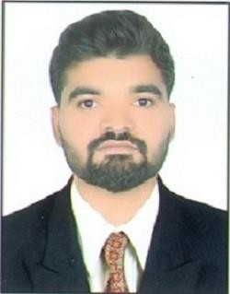

SANKHAT HIMMAT
(ELECTRICAL ENGINEER)
Address-Vadviyala, Gir Gadhada, Gir-Somnath-362530
Mobile +91 99985 65680
Email: sankhathimmat121@gmail.com

Objective
I would like to work in such organization where chance gives to implement my innovative Idea, Skill and Creativity for accomplished the any work or project. I want to utilize my Theoretical Knowledge & Technical skills for achieving the target and developing the performance in the organization or company.

Work Experiences (2019-2020)
I completed 1 year experience from HPCL. HPCL is one of the PSU’s where I work. My location was Jodhpur(Rajasthan). In detail I was learnt from there, Automation knowledge, Office task etc.

- With College Time:
10 day (11/09/2017 to 16/09/2017) Basic of PLC: I have taken training in L.E college Morbi by Siemens company in S7 1200 only. In S7 1200 I have understood the basic of working and basic of programming of PLC, and I had created traffic signal program base on PLC.

Accomplishment Achievement
Sincere, Punctual, Disciplined GATE- 2020 QUALIFIED
MARUTI SUZUKI EXAM- 2020 QUALIFIED

Personal details Languages Known
DOB: 08 feb 1996 Gujrati(Mother Tongue)
Nationality: Indian Hindi(National Language)
Marital Status: unmarried English(International language)
Gender: male

Hobbies Skills
Listen Osho Speeches, Reading Books Quick Learner, Team Collaboration
Games : Cricket, chess, kabaddi Automation, Staff Managment Spreadsheet

Education Qualification

2014-2018 Electrical Engineering From Government Engineering college-Bhuj University: Gujrat Technological University (GTU)

CGPA: 7.95 / 10

March 2014 12th from Shah H D High School, Una. Board-(GSHEB)

Percentage : 67

March 2011 10th from J N Thakkar High School, Vadaviyala. Board-(GSHEB)

Percentage : 71

- Project
TITLE: Automatic Power Factor Correction
We have made this project in last year of EE for future innovation to improve the Power Factor of the Inductive Load. In now days power factor correction in very necessary in industry. In addition Our Country Power Scenario is very large as well inductive load also large.

- Declaration:
The information provided above is true to the best of my knowledge. I will try my best to do the work assigned to me without any postponement. Hope you will give me a chance to prove myself.

