**RESUME**

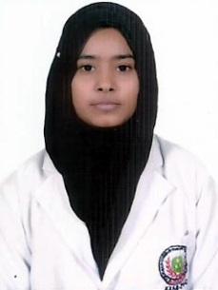

**ADEEVA**

***Address:***

H No. 4/107, Z-25, Asif Nagar, Jamalpur

Aligarh, U.P. (India)

***Cont.:*** 09654509053, 08376973606

***Email.:*** adeebahafeez0077@gmail.com

**OBJECTIVE:**

To serve and organization where the knowledge I have gained can be utilized for the development of the organization goals is to maximize and enhance my skills to Better Serve for the progress of the organization.

**EDUCATIONAL QUALIFICATION**

* High School Passed from UP Board in the year 2008.
* Intermediate Passed from NIOS Board in the year 2014.
* Diploma in Optometry Passed from ACN College, Aligarh in the year 2014-16.
* Bachelor of optometry from Jamia hamdard new Delhi in 2018

**WORK EXPERIENCED AND PROFESSIONAL SKILLS**

* One year as an optometrist from Aligarh eye centre new delhi
* Four months as an optometrist from healing touch eye hospital kamothe, navi mumbai
* Pursuing contact lens six months assessment from Bausch+Lomb mastermind .

Vision

Acceptence

Auto refractometer

PMT

Retinoscopy

Lensometer

Intra ocular pressure(schiotz tonometry)

Syringing

Orthoptics exercise

Visual field ( perimetry )

Occular coherence tomoghraphy

Fundus camera

Non contact tonomertry ( CCT;ACA)

**STRENGTH**

* My strength is positive attitude Sincerity towards my profession and honest.

**PERSONAL DETAILS**

Father Name :- Mr. Hafeez Ahmad

Date of Birth :- 23-11-1991

Sex :- Female

Marital Status :- Unmarried

Religion :- Islam

Nationality :- Indian

Language Known :- English, Hindi & Urdu

**Date:. *(Adeeva).***

**Place**