**RESUME**

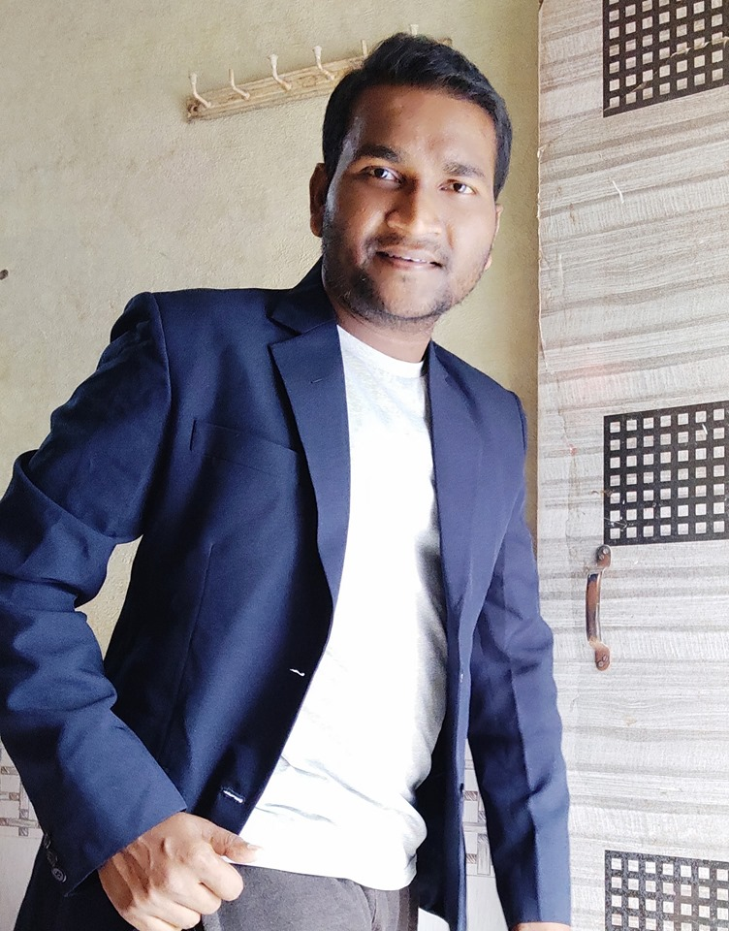**Name – Pramod Vasant Jawale**

**Address: Room 286/75**

**Pada no-3, Parera Nagar,**

**Lokmanya Nagar.Thane (w) – 400606.**

**Contact Mob. No: 9029307075**

**Email ID: pramodjawale55@gmail.**

**------------------------------------------------------------------------------------------------------------**

**Objective:**

To associate myself with affirm that offers a congenial work Environment with ample scope for improvement both on the personal and Professional Front.

**Educational Qualification:**

* **DIPLOMA** in Electrical Engineering passed from (KSOU)
* **H.S.C** passed from Hindi Mumbai board.
* **S.S.C**. Passed from Kolhapur board.

**Technical Qualification:**

* Having **PWD Supervisor** license.(47922)
* **N.C.T.V.T** Completed in Maharashtra state power generation company ltd.
* **I.T.I. Electrical** Stream with first Class passed from Govt. ITI. Chiplun. .
* **Having PASSPORT.**
* **Computer Knowledge:** I have completed MSCIT 1st class passed. Year 2002.

|  |  |
| --- | --- |
| **Word Sheet** | **Window 10, Excel. Microsoft Word.** |
| **Internet** | **E-mails. Web surfing , chime** |
| **Word Spread** | **Word/ /Power Point, Oracle Financials, Outlook Web Access** (**Webmail), Right Crowd. Coupa. Share folder, k.net.** |

**Total experience : 13 years\***

**Achievement: I got a promotion in amazon as a facility Manager.**

**Date July 2020**

**Job details**

**Name of Organization : Amazon India.**

**Designation** **:** Facility Manager.

**Time Duration : July 14 2020 to till date**

**Name of Organization : Amazon India.**

**Designation** **:** Facility Coordinator.

**Time Duration :**  24 Nov.2014.to 13july 2020

**Name of Organization : Mumbai Monorail (Scomi - UTPL)**

**Designation** **:** Sr. Technician.

**Time Duration :** 14Aug-2013to 22 Nov.2014.

**Name of Organization : Shetty Infra Services.** Pvt. Ltd

**Designation**  **:** Maintenance Supervisor**.**

**Time Duration :** 12th Oct. 2008 to 13 Aug. 2013**.**

**Name of Organization : MAHA GENCO .Co. Ltd. (M.S.E.B)**

**Designation :** Electrical (trainee)

**Time Duration :** 09th July 2007 to 08th oct.2008.

Key Skills

* Dedicated and Loyal towards work and organization.
* Ability to work on multiple tasks efficiently.
* Able to work independently.
* Ability to plan, organize, direct, coordinate, control and keep going under tight schedules and pressure
* Ample experience in technical & Administrative work.
* Ability to train, assign, organize, prioritize, motivate, supervise and evaluate
* Ability to use logical and creative thought processes to develop solutions for short term and long term technical needs.
* Ability to develop and implement Emergency Break down Procedures.
* Thorough knowledge Emergency Situation handling.
* Ability to prepare and present accurate and reliable reports containing findings and recommendations.
* Ability to communicate well with others, both oral and in written.

Demonstrate integrity and inventiveness in the performance of assigned tasks

**Job responsibility.**

* **After promotion move to BOM6 site 85k. Sq. ft. area ware house as facility manager handling technical & housekeep department, my direct reporting to regional manager.**

**Amazon.in As a facility coordinator (roll-shift in charge) Period Nov-2014 to till 2020\***

* Handling, 40 no’s of manpower (Technical team & housekeeping team)
* all electrical & mechanical equipment i.e LT ,HT ,DG,UPS , HVAC, Chiller plant, fire pump room, BMS system , conveyors ,VRC & all utility maintenance. Pack station modification, storage rack / aisle modification.
* Vendor management
* Attending all operation call outs & breakdown’s
* Purchase require material raise PR/PO & billing process
* Maintain PPM schedule / MBR /WBR / prepare weekly & Monthly maintenance report , duty roster / raise trouble ticket / incident report / daily wash report / coordinate with operation team , daily update & reverts on outlook mails , change management .
* Attending daily manager meetings , gemba rounds & FM deck calls
* Improve kaizen activity & productivity, new projects handling new FC launch

**Mumbai Mono rail** **(Scomi) as a Sr. technician (Aug-2013 to Dec.2014)**

* Automatic Train wash plant installation to launch & maintenance & operation
* Depo equipment maintenance material store
* Operating & maintenance of forklift, scissor lift, overhead Crain, train wash plant, WTP plant,
* Train root beam changer operating,
* Train root check Engine operating & maintenance,
* Train boogie maintenance
* Run flat tire machine operating & maintenance
* All depot equipment, lighting, LT HT panel’s maintenance.

**Shetty infra service Pvt. Ltd**.**as a multiply roles at 4 site in four years (period 14th Oct.2009 to Aug 2013)**

* **British Gas** corporate head office as a >**Facility executive**
* **Lodha Imperia** 50th floor residential tower site as a > **Maintenance Supervisor**
* **BNP Paribas Bank**, site as a >**Facility supervisor**
* **Capgemini IT Co**. site as a >**Admin assistant**.

**MSEB Maha. Genco**.

* **As a trainee** **1** year complete training in power generation plant 600 megawatt pophli power house & 2000 Megawatt power generation plant at stage -4 Koyna Dam

**Projects Completed.**

**Amazon BOM1 warehouse.**

* + - New conveyor installations at Bom1 site
    - Bom1 relaunch project
    - External warehouse bom1 extension & TBA material storage warehouse handover process.
    - New office & photo studio renewal & setup project
    - Bom1 sound system & PA system improvement.
    - Roof life line installation project
    - Road safety metal barricades & Automatic gate entry system installation project.
    - All power board replaced normal switches to MCB for safety for employee safety
    - I have attending & successfully handle 20 + amazon peak (great Indian sell)

**Amazon BOM4 warehouse**

* + - Chiller installation project In Process and Aisle area to reduce heat index.
    - LED lights fixing in process area, for Energy saving
    - Timer fixing in DB’s for Energy saving
    - Facility & IT room renewal & modification in area.
    - IB new office area setup project
    - Milap 10 no’s of conveyor installation projects at bom4
    - New 45 ft. main gate installation work ,
    - New shelving area installation project,
    - Capacity Enhancement and Dock modifications.
    - Adding new packs station & G+2 racks for improve storage capacity.

**Mumbai Mono rail. Scomi.**

* Train wash plant installation & launching project
* Rail beam replacement switch track installation & operation
* Root checking engine assemble & launching project
* Boogie lifter hydraulic scissor lift installation
* Mono rail inauguration launching project
* New train no, 4 & 5 launch
* Maintenance store develop & setup
* SOP created for All depo equipment

**Shetty Infra service at bellow sites**

* **Capgemini :**MUM 1 office all asset tagging & snag list & New canteen setup
* **BG india :**6th floor whole building painting project & cubic desk modification
* **BNP Bank** :13 floor new office launch setup & chiller plant installation project
* **Lodha paradise:** projects New 50th floor residential tower launch. Garden area & swimming pool, club house gym, Garden area setup, Flat handover

**Personal Details**

**Name : Pramod Vasant Jawale.**

**Date of birth :** 14th feb.1984

**Marital Status :** Unmarried

**Nationality :** Indian

**Languages :** English, Hindi, Marathi

**Strength & Hobbies**

Adaptability, honest, self-motivated, fast decision making. Playing cricket

# Declaration

I hereby declare that the above-mentioned information is correct up to my knowledge and I bear the responsibility for the correctness of the above-mentioned particulars.

**Date:**

**Place: Thane. (PRAMOD VASANT JAWALE)**