**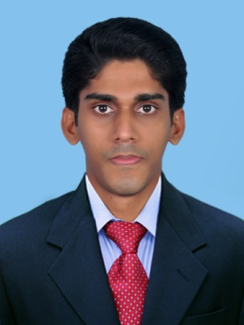*CURRICULUM VITAE***

**Nme ANIL P MANI**

**Mobile 09747452699**

**E-mail anilpmani007@gmail.com**

PROFILE

**• More than 2 years experience in the field of Sales and Marketing,Administration .**

**• Proficient in MS Office (especially on MS Excel and Word).**

**SKILLS**

**• Team player with knowledge in Sales and Administration.**

**• Can adapt quickly to varying business cultures.**

**• Quick at learning new concepts and technologies and putting them to use.**

**• Good communication and interpersonal skills.**

**• Strong organizational skills and ability to manage multiple tasks in parallel.**

**• Setting higher standards of performance.**

**EDUCATION**

* **Bachelors Degree in Mathematics with Computer Applications.**

**Mahatma Ghandi University, Kottayam, Kerala, India**

* **Master of Business Administration (M B A)**

**(MARKETING & FINANCE)**

**St.Berchmans college Chaganaserry , M G University Kerala**

**PROFESSIONAL WORK EXPERIENCE**

**Sales and Marking Manager – sales &marketing June 2016 to January 2019**

**CS Yamaha Motors (Client Safe Yamaha)**

**Sub Dealer of Yamaha Two Wheeler**

**Work Profile**

**• Visit target customer who might benefit from company products and maximize client potential in designed category.**

**• Developing long-term relations with clients, through managing and interpreting their requirements.**

**• Handle showroom operations and field works. Brand promotion**

**• Preparing reports for management, keeping customer records, periodic sales and market reports**

**• Follow up on sales call and maintain customer relationship.**

**• Work closely with Good Ride technical management to provide technical assistance to customers**

**• Responsible to meet monthly sales targets.**

**PERSONAL DETAILS**

**Sex Male**

**Nationality Indian**

**Date of birth 02-10-1992**

**Marital status Single**

**Passport Number L7530453**

**Languages Known English, Malayalam and Tamil, Hindi**

**Decleration**

**I hereby declare that the information furnished above is true and correct to the best of my knowledge and experience.**

**ANIL P MANI**