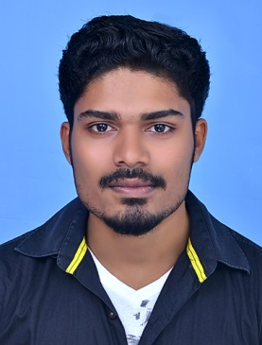  ABY V. MATHEW  Network Associate  Fresher  - Address  Vettamala House  Koothrappally post, Karukachal, Kottayam – 686540  - Email ID  menayanash@yahoo.com  - Phone  +91 980 98 66 981  +91 89 21 46 41 42  - Marital Status  Single  About:  Before the Success completion of Networking Courses including CCNA, CCNA Security and MCSA, I do used my 2 Whole Years preparing for Competitive exams starting 2017 to 2019 last. I’m Having total 3⁺ Years of working experience with Tekcare India Ltd, Samsung India Pvt. Ltd and Galaxy Computer Systems.  Skills:  Computer skills(Assembling and management)  System software and hardware management (troubleshooting)  Active Listening And Managemnt  Strength:  Problem solving and Learning through.  customer relationships.  Languages:  English ●●●●●  Hindi ●●●●●  Tamil ●●●●●  Passport:  Z3402793  References:  Shan (Manager SMEC)  +91 81369 61777 | Technical Skills:  SMEClabs – R&D and Training Wing SMEC Automation Pvt. Ltd.  • Routing protocols on Cisco routers (configuration and troubleshooting) :  ➢ IP IGP Routing: OSPF, EIGRP, RIPv2,  • IPv4, IPv6 and IOS Backup and Password breaking: IP addressing, DHCP, HSRP, IP services, NAT  • Catalyst switch configuration: VLANs, VTP, STP, Trunk, Inter vlan routing, port and vlan security  • ASA Firewall: Access Management, Address Translation, ACLs, IP Routing, Objects Groups, VLANs.  • Switches: 3700 series ,3560 series• Cisco Routers: 1900 | Software:  Windows ●●●●●  MS Office ●●●●●  Windows Server  2012 nd 2016 ●●●●
Professional Experience:

NRN CO-ORDINATOR

Tekcare India Ltd. (Videocon) /Cochin / 2015-2017

- NRN Calls Management.

- Clients Requirements and managements.

- Team Leadership and Service wing management.

- Timely Updation and Follow-up’s to requirements.

- Designing and planning sheets management for service engineers.

- Stock Management and Marketing.

- Providing data level follow-ups to all ASI’s in Zone.

DEALER CO-ORDINATOR

Samsung India Pvt. Ltd. / Kalamasseri / 2014 - 2015

- Dealer Stock Collection, Verification and finalization.

- NDC Collection and Validation

- Stock Management.

- Follow-up’s Regarding Dealer side requirements and needs.

- Recorded, transcribed, and distributed minutes of meetings.

HARDWARE AND SOFTWARE TECHNICIAN CUM SALESMAN

Galaxy Computer Systems, Karukachal / 2013-2014

- Shop Management.

- OS Installation and Troubleshooting.

- Software Management and Hardware installation.

- Door to Door Services and accessory sales in shop.

 | Education:  Cyber Security and Forensic  Cisco Certified Network Associate  CCNA Security  Microsoft Certified Solutions Associate  Degree  B.Sc. Electronics / College Of Applied Science Mallappally.  MG University, Kottayam March – 2014  Higher Education  Plus Two / N.S.S.H.S.S. Karukachal, Kottayam March-2011  Secondary Education  SSLC / N.S.S.B.H.S. Karukachal, Kottayam March-2009 | Achievements & Awards:  MTA - Microsoft Technology Associate / Networking Fundamentals/ Dec 21 - 2019  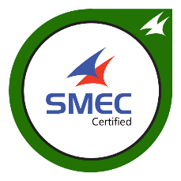
Declaration:
I hereby declare that the details furnished above are true to the best of my knowledge.
Date:
Place: ABY V MATHEW

