Sarwesh Kumar
10 (i) / 2, MIG Complex,  Mayur Vihar Phase-III,  New Delhi – 110096  Mob.No: +91 9899 6918 17  D.O.B. – 09th July 1973  Email : mail2sarwesh@gmail.com | 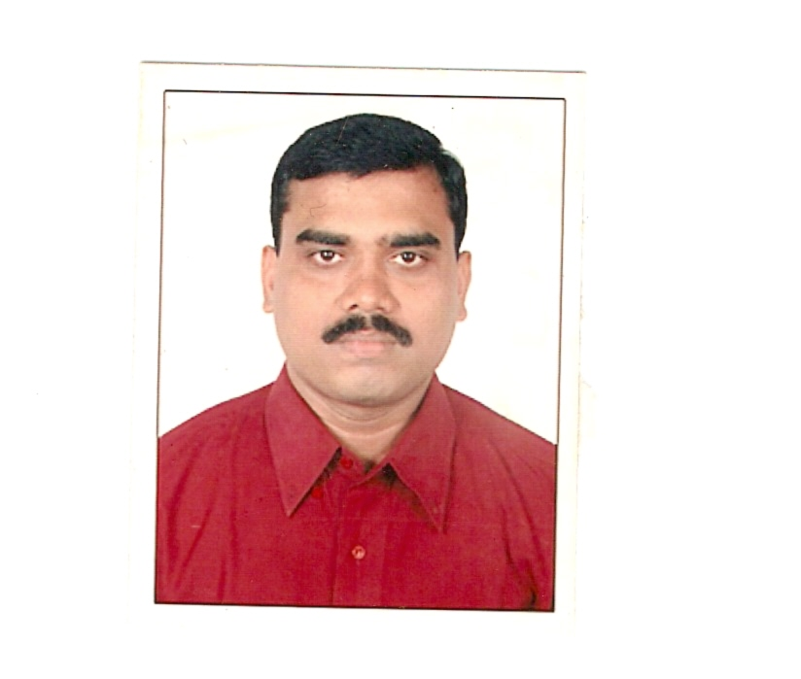
Job Objective

Assignments in Accounts

Summary of Skills & Experience
- Over 25 years’ experience in the areas of Accounts, Sales Tax, Income Tax, TDS and Auditing.
- Proficient in Financial Accounting / statements / MIS / conducting statutory / internal audits / Indirect Taxes – VAT, CST, TDS etc and assistance in preparing budgets.
- Conversant with computerised accounting systems and handling matters relating to Income Tax, Sales Tax, TDS and other Statutory Acts.
- Excellent Relationship Building and Analytical Skill.

Organisational Experience:

Career Path with significant accomplishments:
- Since Oct’2011 to till date Merlin Exim Pvt. Ltd. Asst. Manager Accounts
(A leading manufacturing group of Hotel Furniture)

- Cash and Bank
- Financial Accounting up to Balance Sheet Preparation
- Receivable Controls
- Payable Controls
- Sales Tax
- TDS
- GST
- Overall Supervision of Accounts
- Stores Monitoring

- Since Sept’06 to Sept’11 Ochoa Laboratories Ltd. Asst. Manager Accounts
(A Pharmaceutical Company)

- Looked after Indirect Taxes - Sales Tax and Tax Deducted at Source.
The company had its Sales Tax Registration Number in Delhi, Utter Pradesh, Uttaranchal and Madhya Pradesh. Along with own registration numbers company has Consignee Sales Agents all over India.
- Accounting of Construction of Pharmaceutical Manufacturing Plant at Samba, Jammu.
- Looked after CSAs Accounts and Debtors Control.
- Looked after works of HR department like Preparation of Salary Sheet, Calculation of TDS of Staff, ESI and PF deposit, ESI & PF Return etc.
- Looked after overall accounts work.

- Since Oct’05 to Aug’06 Devi Sahai Charan Dass Ass. Accounts-In-Charge-Polymer Div.
(An Associate of Reliance Industries Ltd.)
- Streamlined the accounting system that increased efficiency in operations.
- Did the pending Reconciliation of big Accounts of its principal Reliance Industries Ltd. & Indian petrochemicals Corporation Ltd. and other big customers.
- Looked after Financial Accounting, TDS, maintenance of Bank Accounts and monitoring & follow up of about 100 clients.
- Independent handling of Accounts of the Division.

- Oct’00 to Sept’05 Chinmaya Centre of World Understanding Accounts Officer
(A renowned Spiritual Centre)
- Financial Accounting up to finalisation of accounts.
- Preparation of Receipt & Payment of every spiritual and cultural event.
- Looked after complete Accounts of Delhi Chinmaya Mission Trust and Chinmaya Mission.
- Looked after Financial Accounting and TDS of the centre and School (Chinmaya Vidyalaya) run under auspices of the centre.
- Apr’96 to Sep’00 Mega International Pvt. Ltd. Accounts Officer
(A Pharmaceutical Company)
- Dealt with Bank for Cash Credit Limits
- Looked after Financial Accounting and TDS
- Looked after C & F’s Accounts.
- May’95 to Mar’96 C.P. Maini & Co. Accounts & Audit Asst.
(A Chartered Accountant’s Firm)
- Audit of Sole Proprietorship Business, Partnership Firms and Companies.
- Internal Audit of National Banks.
- Internal Audit of Citi Bank for Import documentations.

Key Responsibilities

Finance & Accounts

- Preparing and maintaining books of accounts conforming to time and accuracy norms.
- Presenting a true and fair view of the financial position of the company by way of timely preparation of P&L Account and Balance Sheet.
- Formulating Annual Budgets analysing variations between the budgeted and the actual expenses.
- Coordinating with ESI & PF Departments for meeting statutory requirements.
- Actively involved in determining job costs during the production process.
- Making MIS / financial reports to help management take financial decisions and formulate corporate financial objectives.

Taxation & Auditing

- Ensuring proper calculation of taxes and timely filing of returns including Sales Tax, TDS & TDS Returns keeping compliance with the Act and assessment of the same.
- Appearing before the I.T. authority for resolving tax related issues.
- Conducting internal / statutory / bank audits to ensure that accounts are prepared and maintained as per the pre-set accounting standards.
- Implementing recommendations made in the Audit Reports pertaining to finance, statutory compliances and processes.

Commercial Operations

  - Liaising with banks for opening and operating Term Loan, L/Cs, discounting of Bills and obtaining Cash Credit Limit.
  - Handling CSA Operations including Debtors Control and collection of Depot dues.
  - Creditors Control
  - Debtors Control

IT Skills

- Well versed with Tally, MARG, MS-Office & Internet Applications. Can handle any FA Software.

Educational Qualification

- B.Com. (Accounts Hons.) from Patna University
- M.B.A. (Finance) from IILM University

Location Preferred: Delhi & NCR but AISL is accepted if other things are ok.

Salary Drawn: Rs. 6.38 Lakhs PA

Salary Expected: Negotiable

With Kind Regards

At HIS feet

(Sarwesh Kumar)

