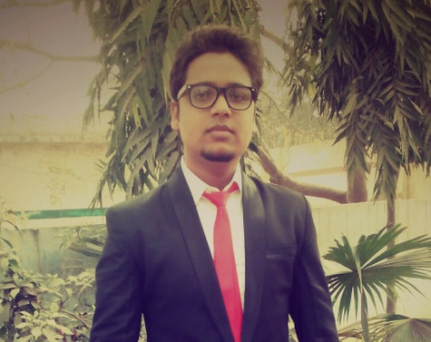**RESUME**

**NITIN VERMA**

H NO E -502 Ram Nagar Gali No.-2,

Kanker Khera, Meerut Cantt.

Mob. NO:- 08449997825, 08077308327

E.mail-vermanitin992@gmail.com

**PROFILE**

To be honest with my work and organization whomsoever I join my ambition to make myself progress and my organization in each step of life.

**ACADEMIC QUALIFICATION:-**

* High School from C.B.S.E Board in 2012.
* Intermediate from U.P. Board in 2014.
* B.A Passed from CCS University in 2017.

**SKILLS:-**

* Basic knowledge of computer.
* English Typing.
* Adobe photoshop
* Excel
* Ms Office
* E Commerce Handling

**EXPERIENCE:-**

* Two years Experience in Sareen Sports Industries as a Area sales Incharge Meerut.
* Three Year Experience Meerut Collection Centre Behalf On Hdfc Bank as Recovery Department Meerut
* Present Working Magma Finance Ltd Designation .(Field Officer)

**PERSONAL DETAILS:-**

**Father’s name** : Mr. Arun Verma

**Date of birth** : 06-11-1994

**Gender** : Male

**Nationality** : Indian

**Marital status** : Married

**Language known** : Hindi/English

Date_________________

Place ________________  **(NITIN VERMA)**