# **CURRICULAM VITAE**

# ARNAB CHAKRABORTY

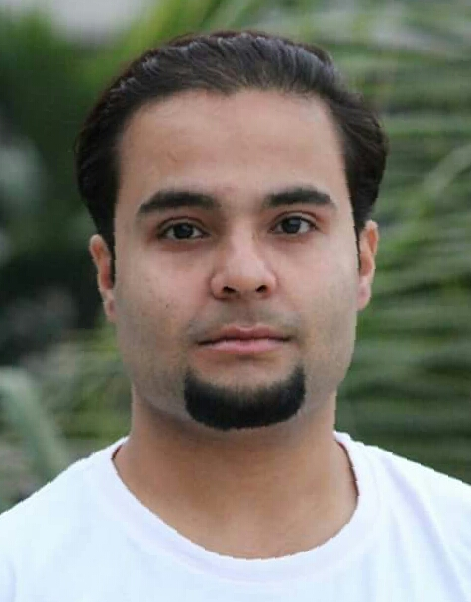

**ABOUT ME**

GAURDIAN’S NAME : Mr. Anjan Chakraborty

ADDRESS : 314, R.N. Tagore Road, Kolkata-700077

DATE OF BIRTH : 15.01.1992

GENDER : MALE

NATIONALITY : INDIAN

CONTACT NO. : +91 8961230307

EMAIL ID. : [arnabchakraborty234@gmail.com](mailto:arnabchakraborty234@gmail.com)

CAREER OBJECTIVES:-

* Seeking a career to utilize my knowledge and personal skills to gain practical learning under a reputed organisation.
* To take sincere responsibility and contribute significantly towards the desired company.
* Aiming to build within the organisation a vibrant and stimulating environment where the application of my skills and development of company goes hand in hand.

**EDUCATION**

|  |  |  |  |  |  |
| --- | --- | --- | --- | --- | --- |
| Qualification | | Year | Institution | | %(Agg.) |
| POST GRADUATION | | | | | |
| MBA-Human Resources ,Finance  ( SEM 1 & 2) | | 2015 | ST. MARY’S TECHNICAL CAMPUS,KOLKATA | | 63.80% |
| MBA-Human Resources ,Finance  (SEM 3 & 4) | | 2016 | ST. MARY’S TECHNICAL CAMPUS,KOLKATA | | 75.60% |
|  | |  | DGPA | | 69.70% |
| GRADUATION | | | | | |
| BBA ( SEM 1 & 2) | | 2011 | GEORGE COLLEGE,SEALDAH | | 56.70% |
| BBA (SEM 3 & 4) | | 2012 | GEORGE COLLEGE,SEALDAH | | 59.20% |
| BBA (SEM 5 & 6) | | 2013 | GEORGE COLLEGE,SEALDAH | | 65.00% |
|  | |  | DGPA | | 60.03% |
| 10TH AND 12TH STANDARDS | | | | | |
| Higher Secondary (WBCHSE) | 2010 | | | Sinthi R B T Vidyapith | 48.00% |
| Secondary (WBBSE) | 2008 | | | Sinthee Ramkrishna Sangha  Vidyamandir | 64.00% |

**INTERNSHIPS AND TRAININGS**

2016 : Underwent summer training at Narayana Super Speciality Hospital (Barasat) for a period of 1 month.

**Work experiences**

2017 : Was appointed as Sales Officer under the Finance Department of Larsen & Turbo Pvt Ltd. (L & T).

2012 : Worked as Data Entry Operator at various events.

**Extra-curricular activities**

* Contributed at the relief fund during the devastating flood at Malda in the year 2017.
* Runners up Inter Departmental Quiz competition and was awarded with a memento.
* Participated in Inter Departmental Football Tournament in the year 2013.
* Worked as a volunteer at the promotion of Nissan Micra Four Wheeler.

**SKILLS**

* Leadership and Management qualities
* Workaholic
* Computer Proficiency: Operating Systems : Windows XP / 7/8/10

Office Status : Knowledge of Ms-Office.

Internet : E-mail, Surfing & All related tasks

* Sales Related Work such as identity verification, collecting documents etc.
* Good Communication Skills

**LANGUAGES**

BENGALI; ENGLISH; HINDI

**INTERESTS**

* Listening to music
* Animal Lover
* Travelling
* Nature lover

DECLARATION

I declare that all the above information and details are true and correct to the best of my knowledge and belief.

**PLACE**: KOLKATA 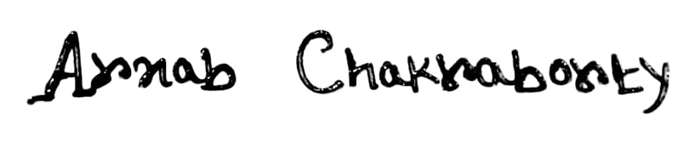

**DATE** : 23/08/2018 ………… ………… ……………………………

(ARNAB CHAKRABORTY)

***************