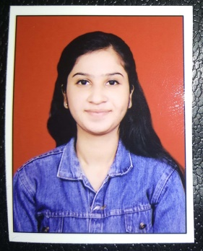**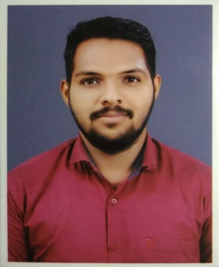 RESUME**

**Poonam Prakash Kamble**

[**poonamkamble9850@gmail.com**](mailto:poonamkamble9850@gmail.com)

+91 8766725520/8624878439

|  |
| --- |
| CAREER OBJECTIVE |

I want to be a part of this organization where I can fully utilize my skills and effort and make significant contribution to the success of the company organization and with the same time my individual growth

|  |
| --- |
| EDUCATIONAL QUALIFICATION |

|  |  |  |  |  |
| --- | --- | --- | --- | --- |
| **Course** | **University** | **Institute** | **Year of Passing** | **SGPA/Percentage** |
| B.E in Computer Engineering | Savitribai Phule Pune University | Modern Education Society's College of Engineering, Pune-01 | 2019 | Aggre .CGPA- 6.62 |
| Diploma in Computer Engineering | State Board | Jayawantrao Sawant Polytechnic, Hadapsar ,Pune | 2016 | 73.56% |
| SSC | State Board | Basant High/Primary School | 2013 | 67.82% |

|  |
| --- |
| TECHNICAL SKILLS |

Languages: C, C++, Core Java, Advanced java.

Database: Oracle, MySQL.

|  |
| --- |
| PROJECTS |

* **B.E project - "Author Identiﬁcation by using Data Mining Techniques"**

Author Identiﬁcation is used for determining which author wrote a chapter or passage of a book, the Bible being the most famous example. The process of identifying the author of their word choice, sentence structure, etc.

* **T.E (2nd semester) computer Engineering in B.E, Mini Project- "Object Detecting Robot"** Design an autonomous robot which when detects any obstacles in its path, would change direction to avoid collision.
* **Final year project in Diploma Computer Engineering -"Railway reservation system"**

The project provide the facility for maintain information about passenger and train. The software uses MS Access as the Back-end and Visual Basic as the Front-End

|  |
| --- |
| ACHIEVEMENTS & AWARDS |

* MS-CIT - Obtained 90/100

|  |
| --- |
| HOBBIES |

Cooking, Listening song, Playing Badminton.

|  |
| --- |
| PERSONAL STRENGTHS |

* Quick learner
* Hard worker
* Team player
* Innovative thinking
* Analytical mindset
* Updated information about the sector

|  |
| --- |
| PERSONAL PROFILE |

* Date of Birth : 29-07-1996
* Father name : Prakash Tukaram Kamble
* Mother name: Sukumar Prakash Kamble
* Address : Sr.no-71, Colony no-3,Balaji Nagar, Ghorpadi Goan Pune- 01
* Known Languages : English, Hindi, Marathi

|  |
| --- |
| DECLARATION |

I hereby assure that the above Information is true to the best of my knowledge.

Date:   13/11 /2019

Place: Pune