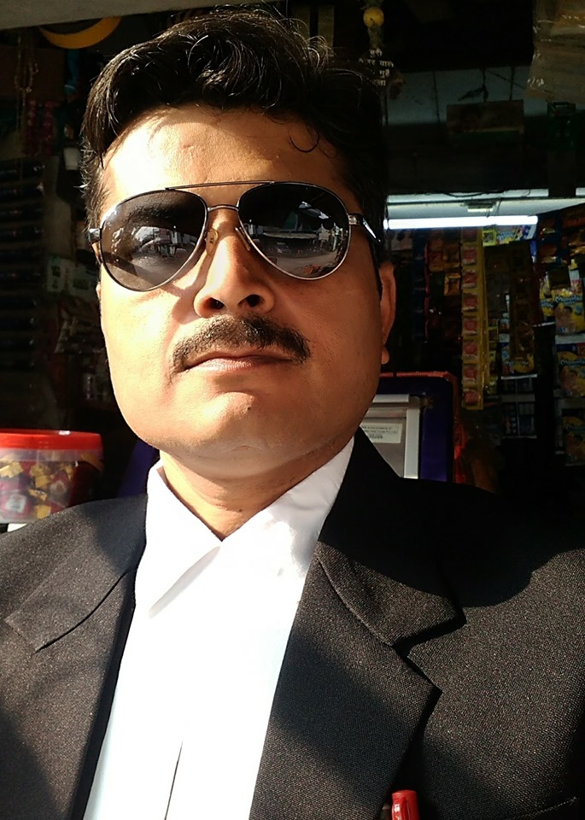

ANJANI MISHRA
145/84G RASOOLABAD, TELIARGANJ, Allahabad, 211004
Contact: +91- 9415710410, 7786036478 Email: Anjanippsalld@gmail.com

Dear Sir/Madam:

With almost 10 years dedicated to the education field, I write to request consideration for a position with your institution. I offer significant skills in achieving academic excellence in students and enhanced institutional growth through effective management of facilities and resources and am confident of transferring these to your concern with immediate effect.

As a close review of my enclosed resume will reveal, I have held a diverse portfolio as Academic coordinator in Senior Secondary School, Allahabad. In the process, I developed strong man management and interpersonal skills able to interact, monitor and foster further growth among students, teachers and parents.

With my track record for excellence, resource, initiative and leadership and active participation in numerous curricular as well as extra-curricular activities and initiatives; and singular delight in connecting with and molding young minds according to the needs of the changing times, I believe I have much to offer. Details of my background and contributions are documented in the enclosed résumé, and it is with complete confidence that I present them as representative of the value and return on investment that I will bring to your organization. Thank you for your time and consideration.

Sincerely,

ANJANI MISHRA

ANJANI MISHRA
145/84G RASOOLABAD, TELIARGANJ, Allahabad, 211004
Contact: +91- 9415710410, 7786036478 Email: Anjanippsalld@gmail.com

Advocate, Allahabad Highcourt
Enrolment No. UP K/07151/2018 (Bar Counsel of Uttar Pradesh),
Dedicated to Creating a Positive enviornment and to work in challenging atmosphere which provide ample opportunities for earning and growth as Providing superior Legal Services

PROFILE:

- Seeking to Lead an institution in Legal matters and to provide superior Legal Services, by effectively utilizing skills and talents garnered from career spanning almost 15 years in Sales, Customer care, Back office operation, Business Analysis, Education and Legal . Currently performing in the capacity as Legal Advisor/Advocate in Allahabad Highcourt, Allahabad.
- Offering extensive exposure in handling CIVIL AND CRIMINAL WRIT PETITIONS, ARBITRATION & CONCILATION MATTERS, INDUSTRIAL DISPUTES CASES / LABOUR LAW CASES, CHEQUE BOUNCE MATTERS (138 N.I ACT CASES ), LAND AQUSITION MATTERS.
- CIVIL SUITS- SUIT FOR RECOVERY, SPECIFIC PERFORMANCE CASES , SUMMARY PROCEDURE UNDER ORDER 37 OF C.P.C ,SUIT FOR PARTITION AND SUIT FOR POSSESSION , SUIT FOR DAMAGE, SUIT FOR DECLARATION , SUIT FOR INJUNCTIONS (STAY), NEGOTIABLE INSTRUMENT CASES (UNDER SECTION 138 OF N.I.ACTS), RENT CASES MARRIAGE & DIVORDE ,MAINTENANCE AND ADOPTIONS CASES .
- CONSUMER CASES - DISTRICT CONSUMER FORUM, STATE CONSUMER DISPUTES REDRESSAL COMMISSION & NATIONAL CONSUMER DISPUTES REDRESSAL COMMISSION
- INSURANCE MATTERS - Motor Accident claims ,Damage cases
- COMPLAIN CASES/CRIMINAL CASES & STATE CASES - Under section 156(3)and section 200 of criminal procedure code , Anticipatory Bail and Regular Bail, Dowry cases
- Drafting of Commercial Agreements & Contracts.
- Accident Claim & Compensation
- Debts Recovery Tribunal,

CORE COMPETENCIES
• Legal Advice
• Coordination
• Innovative Curriculum Development
• School Management/ Classroom Management/Parental Involvement
• Teacher/Student Assessment
• Hands on instruction/ Process Training/ Teachers Training
• Administration/Back office management
• Direct Sales/In-direct selling

PROFESSIONAL EXPERIENCE

ALLAHABAD HIGHCOURT, ALLAHABAD From Dec 2018

ADVOCATE/LEGAL ADVISOR

LDC PUBLIC SCHOOL, SORAM, ALLAHABAD From July 2018 TO NOV 2018

VICE PRINCIPAL

PRAYAG PUBLIC SCHOOL & COLLEGE, ALLAHABAD 2013-2018

ACADEMIC COORDINATOR

STERIA INDIA LIMITED, NOIDA 2010- 2013
TEAM LEADER

EXL SERVICE.COM (I) PVT. LTD, NOIDA 2005-2010
SUBJECT MATTER EXPERT

SAMSUNG INDIA ELECTRONICS LIMITED, ALLAHABAD 2000-2005
CUSTOMER SERVICE COORDINATOR

CMI INTERNATIONAL, ALLAHABAD 1999-2000
DIRECT SALES EXECUTIVE

Academic Credentials

LL.b
CSJM UNIVERSITY KANPUR
2018

B. ED
CCS UNIVERSITY, ALLAHABAD
2010

MBA (SPECILISATION IN OPERATIONS)
SYMBIOSIS CENTRE FOR DISTANCE LEARNING , SYMBIOSIS UNIVERSITY (PUNE)
2008

M .A. (ECONOMICS)
CSJM UNIVERSITY (KANPUR)
2002

B.A (POLITICAL SCIENCE, EDUCATION, ANC HISTORY)
ALLAHABAD UNIVERSITY (ALLAHABAD)
2000

SR. SECONDARY (PHY, CHEM, BIO)
BOARD OF SENIOR SECONDARY EDUCATION, UTTAR PRADESH
1996

SECONDARY (10TH)
BOARD OF SENIOR SECONDARY EDUCATION, UTTAR PRADESH
1994

Additional Information

Father’s Name : | Mr. Ramesh Chandra Mishra
Languages: | English, Hindi
Date of Birth: | August ’1978
Permanent Address: | 145/84G Rasoolabad, Teliarganj, Allahabad, 211004  Contact: +91- 7786036478, 9415710410

