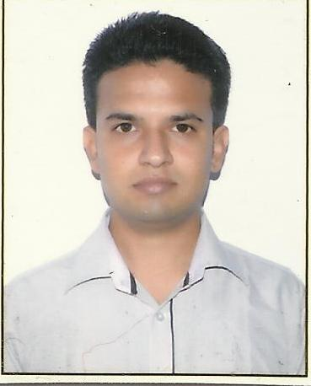 **Curriculum Vitae**

Arjun Bhola

E-mail: arjunbhola16@gmail.com

Add: B-115, Street No. 6, Meet Nagar

New Delhi – 110094.

Contact# 7906022756, 9568846558

**OBJECTIVE**

Seeking a challenging position in the field of Finance & Accounts and strive for excellence - with a positive attitude that will fully utilize my skills for the fulfillment of organizational goals.

**CORE COMPETENCIES**

* Accounting
* Auditing
* Taxation
* Finance

**WORK HISTORY**

* Worked 1 years and Eight Months as an Article/Audit Assistant in Gulati Sharma & Associates, Chartered Accountants, Meerut from April 2013 to December 2014.
* Worked 1 years and Two Months as an Article/Audit Assistant in Piyush Rastogi & Co., Chartered Accountants, Delhi from Jan 2015 to March 2016.
* Worked 1 Years as an Accounts Profile in P.Singh & Co., Chartered Accountants, Meerut from April 2016 to February 2018.
* Presently working as an Accounts and Taxation Profile in Singhi Chugh & Kumar, Chartered Accountants Firm, Delhi from March 2018 to Till Now.

**KEY Deliverables**

* Day to Day Accounting of Individual, Firm and Companies.
* Prepare Invoices from Tally and Softwares.
* Prepare Income Tax, TDS return & revisions and GST Returns and also filed.
* GST Reconciliation with GSTR 2A on Monthly and Yearly Basis.
* GSTR - 9 and GSTR 9C Preparation and filed.
* Maintaining track record of Company’s expenses.
* Prepare Salary Sheet including PF and ESI Matters.
* Finalization of Books of Accounts.
* Bank, Internal and Statutory Audit.
* Finalized Financial Statement of Firms and Companies etc.

**PROFESSIONAL QUALIFICATION**

* Cleared CA-Inter Ist Group in November 2012.

**EDUCATIONAL QUALIFICATIONS**

* B.Com 2013 C.C.S. University, Meerut Second Division
* Class XII 2010 State Board First Division
* Class X 2008 State Board First Division

**ADDITIONAL INFORMATION**

* Completed ‘Orientation Program’ Conducted by The Institute of Chartered Accountants of India.
* Completed ‘Information Technology Training’ (ITT) Conducted by The Institute of Chartered Accountants of India.
* Completed Computer Basic and Tally Course From Nav Bharat Computer Education Centre.
* Completed GMCS (General Management Communication Skills) Conducted By The Institute of Chartered Accountants of India.

**COMPUTER SKILLS**

Operating Systems: Windows 7, Windows XP etc.

Applications: Microsoft Office 2010 (MS-Excel, Word etc.) and Internet.

Software: Tally ERP 9, Spectrum, Compu-tax, Taxmann, CCHIFIRM, GST Portal.

**PERSONAL INFORMATION**

Date of Birth: 16th January, 1992

Marital Status: Single

Father’s Name: Late Shri Vijay Kumar Bhola

Languages Known: Hindi, English

Nationality: Indian

I hereby declare that the information furnished above are true to the best of my knowledge.

Place: Delhi

Date: **( ARJUN BHOLA )**