CURRICULUM VITAE

Monish Panicker
Kochuvattukulam House
Vadakkenada, Ettumanoor Temple
Ettumanoor,Kottayam
Kerala , India
Pin- 686631
E-mail: monishpanicker127@gmail.com 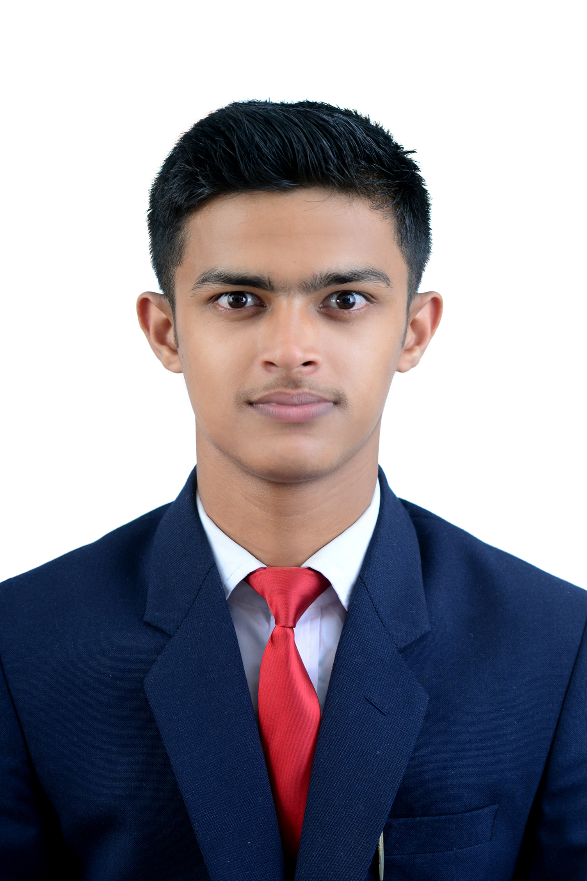
Mobile: 7907381045
Career Objective:
To work with an organization where my efforts will be complimented by career growth and I can gain experience and enhance my abilities in meeting the ever-growing hospitality needs

Skills  - Strong customer service skills  - Strong communication skills  - Problem solving Skills  Academic Qualifications  - Pursued B.SC(Hospitality & Hotel Administration from IHMCT, Kovalam  - 12th from C.B.S.E in 2008 with 60%  - 10th from C.B.S.E in 2006 with 62%.  Areas of expertise  - Knowledge of Front Office terminology  - Expertise in various types of Indian sweets and cuisines  Passport Details  Passport no.:- S2923850  DOI :- 08/06/2018  DOE:- 07/06/2028 | Industry Exposure
- Completed industrial training from Hyatt Regency, Delhi during the period December 2017 to April 2018 in the areas of Front Office, Housekeeping, F and B services and Food Production
- Assisted in Outdoor catering in the Leela, Kovalam during Sep 2016
- Worked as shift manager in Domino's pizza.
Certifications and IT Skills
- Certified Food Safety Supervisor catering (Level 2)
- Working knowledge of Property Management System Software in the areas of administrating reservations and managing hotel inventory

Activities and Achievements
- Participated in Fandango Food Fest as a volunteer in Management team
- Participated in Theme Dinner as part of cultural team
- Participated Swatch Bharat Abhiyan 2017 at Kovalam Beach in association with the Indian Coastal Guard and Indian Coastal Police

Hobbies
- Travelling
- Music

Personal Details
- Date of birth - 09-01-1999
- Father’s Name – P J Mohana Panicker
- Languages known - English, Hindi and Malayalam
- Marital status – Single

References
- Name and Position- Nirmala Jacob, Senior lecturer, Training and Placement Coordinator, IHMCT, Kovalam
- Phone-944758686
- Email-it@ihmctkovalam.org

