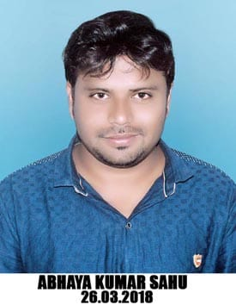**ABHAYA KUMAR SAHU**

Photo

S/o-Dillip Kumar Sahu

**At. - Tangarpada, Bhatli Road Bargarh - 768028 (Odisha)**

**E-mail :** [**abhayasahu12@gmail.com**](mailto:abhayasahu12@gmail.com) **Mobile - +91 9556219933**

# Career Objective :

To work for an organization which provides me the opportunity to improve my skills and knowledge to growth along with the organization objective.

# Academic Qualifications :

|  |  |  |  |
| --- | --- | --- | --- |
| **UNIVERSITY PASSOUT** | **SCHOOL/COLLEGE** | **UNIVERSITY** | **YEAR OF PASSING** |
| **MATRIC** | **GEORGE HIGH SCHOOL BARGARH** | **B.S.E. ODISHA** | **2007** |
| **+2** | **TORA COLLEGE BARGARH** | **C.H.S.E.** | **2011** |
| **BA** | **KANTAPALI COLLEGE KANTAPALI** | **SAMBALPUR UNIVERSITY** | **2014** |

## Computer Skills :

Comfortable in working with OS environments like window-xp, windows vista, windows-7 etc.

MS word and internet application, DCA, PGDCA, Tally

## Work Experience

 TVS Showroom Sales Executive 1 year

 Indian fleet sales oil executive1.2 Years

## Hobbies :

Love to watch Movies and Riding Bikes.

## Personal Profile :

**Name : Abhaya Kumar Sahu**

**Date of Birth : 12-07-1992**

**Nationality : Indian**

**Languages Known : English, Hindi and Odiya**

**Declaration**

I hereby declare that the above furnished information is true to the best of my knowledge.

Place : Bargarh **Abhaya Kumar Sahu**

Date :