**RESUME**

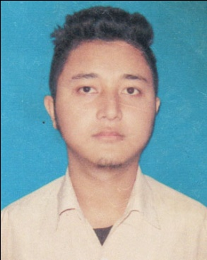

**MITHINGA WARY**

**PRESENT ADDRESS:** Gossaigaon Gwjwnpuri, Padmabil

P.O. & P.S -Gossaigaon

Dist: Kokrajhar, State: Assam

Pin- 783360

**Email: mithinga111333@gmail.com**

**Mobile No: 8876404715, 8876440671**

**CAREER OBJECTIVE:**

To work for an organization which provides me the opportunity to improve my skills and knowledge to growth along with the organization objective.

**ACADEMIC PROFILE:**

**EDUCATIONAL QUALIFICATION:**

|  |  |  |  |  |  |
| --- | --- | --- | --- | --- | --- |
| **Sl. No.** | **Qualification** | **Institution** | **Board** | **Year of Passing** | **% of Marks** |
| 1. | HSLC | Ascent Academy E.M. High School, Guwahati | SEBA | 2013 | 60% |
| 2. | HSSLC | Gossaigaon College, Gossaigaon | AHSEC | 2015 | 49.6% |

**WORKING EXPERIENCE:**

* **Freshers**

**SOFTWARE/ITSKILL:**

* **Diploma in Computer Application (6 months)**

**GEOGRAPHICAL LOCATION PREFERRED:**

* **Anywhere in India**

**COMMUNICATION SKILLS:**

|  |  |  |  |
| --- | --- | --- | --- |
| **Language Known** | **Read** | **Write** | **Speak** |
| *Assamese* | *Yes* | *No* | *Yes* |
| *Hindi* | *Yes* | *Yes* | *Yes* |
| *English* | *Yes* | *Yes* | *Yes* |
| *Bodo* | *Yes* | *Yes* | *Yes* |

**PERSONAL QUALITIES:**

* Hard worker.
* Willingness to learn new things.
* Disciplined & good etiquette.
* Positive thinker.

**PERSONAL DETAILS:**

*Name : Mithinga Wary*

*D.O.B : 1st February 1995.*

*Father’s Name : Lt. Reken Wary*

*Mother’s Name : Mira Wary*

*Nationality : Indian*

*Religion : Christian*

*Marital Status : Unmarried*

*Permanent Address : Gossaigaon Gwjwnpuri, Padmabil*

*P.O. & P.S.: Gossaigaon*

*Dist.: Kokrajhar (Assam)*

*Pin: 783360*

**DECLARATION:**

*The above information given is true to the best of my knowledge and belief.*

***Date: …………………..***

***Place: Gossaigaon Signature of Applicant***