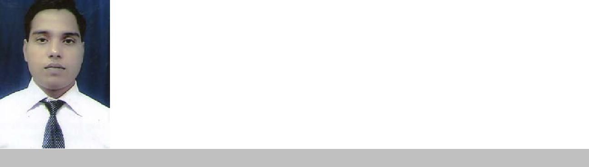
Curriculum Vitae

Avinash Kumar, E-mail: avinashkumar04@gmail.com, Contact Number: 9199895670, 6207627577

Career Objective:

I want to work in a vibrant organization, which provide me a good knowledge in the field of Liaisoning which enhance my competencies by working for the growth of an organization.

Employment History:

Name of the Institution | Designation | Duration | Location
HDFC BANK LTD | SALES | June2010 to | New
 | EXECUTIV | June 2011 | Delhi
 | E
AXIS SALES LTD | SALES | Feb 2010to | New
 | EXECUTIV | May 2010 | Delhi
 | E
Job Profiles:

HDFC BANK&AXIS SALES LTD NEW DELHI
SALES EXECUTIVE.

- Handling customers in a branch lobby and handling their queries.

- Executing customer instructions.

- Resolving customers queries in a very first point of contact..

- Account opening like CASA & DMAT.

- Report Generation & filing.

- Perform other activities like Credit cards, FD Booking, A/C transfer, , calling for insurance renewal and providing leads for CASA (current account  savings account) opening, insurance.

Process Management

- Implementing service standards and guidelines that serve as benchmark for excellent service delivery thereby contributing towards ameliorated service revenue generation.

- Following the process / procedure of the bank & ensuring compliance to rules and regulations of the bank including latest circulars & notifications.

- Initiating contact with potential customers for developing leads, sales & cross selling banking products.

Client Relationship Management

- Forwarding customer instructions to the concerned department & ensuring customer satisfaction by achieving delivery & service quality norms.

- Building and maintaining healthy business relations with clients, ensuring high customer satisfaction matrices by achieving delivery & service quality norms.

SKILL SETS

- Very soft spoken, Self motivated.

- Good in handling customers in the branch lobby with minimal wait time.
1
- Cross selling.

- Expert in communication with the customer.

CURRENT WORKING IN KGVK AGRO LTD RANCHI AS OFFICER

From-27-05-13 to 15th July 2019

KGVK Agro Ltd. Ranchi-Job Profile Details

- Effective managing sales & market development for setting up AGRI business in the specified territory/markets/rural marketing

- Meet District Agriculture officer, DPM, Different district in Jharkhand.

- Liaisoning with various department of government of Jharkhand, Bihar,MP regarding our business.

- Liaisoning With different Ngo’s head like deshpande foundation,Hubbli,Cimmyt Bangladesh,JSLPS,BRLPS,ASRLM

- Facilitated resolution of customer requirements..

- Maintained detailed records of contacts made, issue discovered and action taken to resolve.

- Understating the clients requirements & providing quality service.
- Team management.

- Planned, managed and coordinated all fielding team activities.

- Documentation and reporting.

Professional Qualification

PGDM from Institute of Professional Excellence & Management, Ghaziabad, 2010

Area of Specialization

- MARKETING

- FINANCE

Educational Qualification:

- Graduation: B.Com, T.G.C, Bokaro from Vinoba Bhave University, Hazaribagh, 2008 .

- Intermediate: I.Sc.from J.A.C,Ranchi ,2005.

➢ High School:  Matriculation from J.S.E.SB,Ranchi.,2002.

Summer Internship

- Religare Securities Ltd. New Delhi .(8 weeks)

- Project Title: comparable analysis of Religare Securities Ltd.

Live Project:

Brand image of axis bank ltd,new delhi,8 weeks

Personal Traits:

- Effective planning and organizational skills.
- Dynamic & Hardworking.
- Good in team work.
- Ability to successfully manage multiple priorities and assignment.

Language Proficiency:

Language |  | Ability to Converse |  |  |  | Ability to Read |  |  |  | Ability to Write
 |  | Poor | Fair | Good |  | Poor | Fair | Good | Poor |  | Fair | Good
English |  | - | √ | - |  | - | - | √ | - |  | - | √
Hindi |  | - | - | √ |  | - | - | √ | - |  | - | √
Hobbies/ Extra-Curricular |  |  |  | Activities:
I am playing cricket ,watching amitabh movie &adventural programe
Personal Details:
Date of birth |  |  |  |  | : 15 JANUARY1987
Sex |  |  |  |  | : Male
Nationality |  |  |  |  | : Indian
Marital status |  |  |  |  | : Single
Permanent Address |  |  |  |  | : S/O Birendra Sharma,
 |  |  |  |  |  | G m colony dhori,
 |  |  |  |  |  | Bokaro jharkhand-825102
 |  |  |  |  |  | Mobile No.: 9199895670

Declaration
I solemnly declare that the above information is true and correct to the best of my knowledge.

Date: - 22/03/21
Place:- RANCHI (AVINASH KUMAR)

4

