CONTACT INFO

Dwarikapuram colony, near S R petrol pump , Azizganj Shahjahanpur , UP

utkarshdixit1810@gmail.com

+91 9897782377

SKILLS SUMMARY

Python

HTML

CSS

Java Script

PHP

SQL

AWARDS RECEIVED

Won 2nd Position in Art and Creativity in School

UTKARSH DIXIT
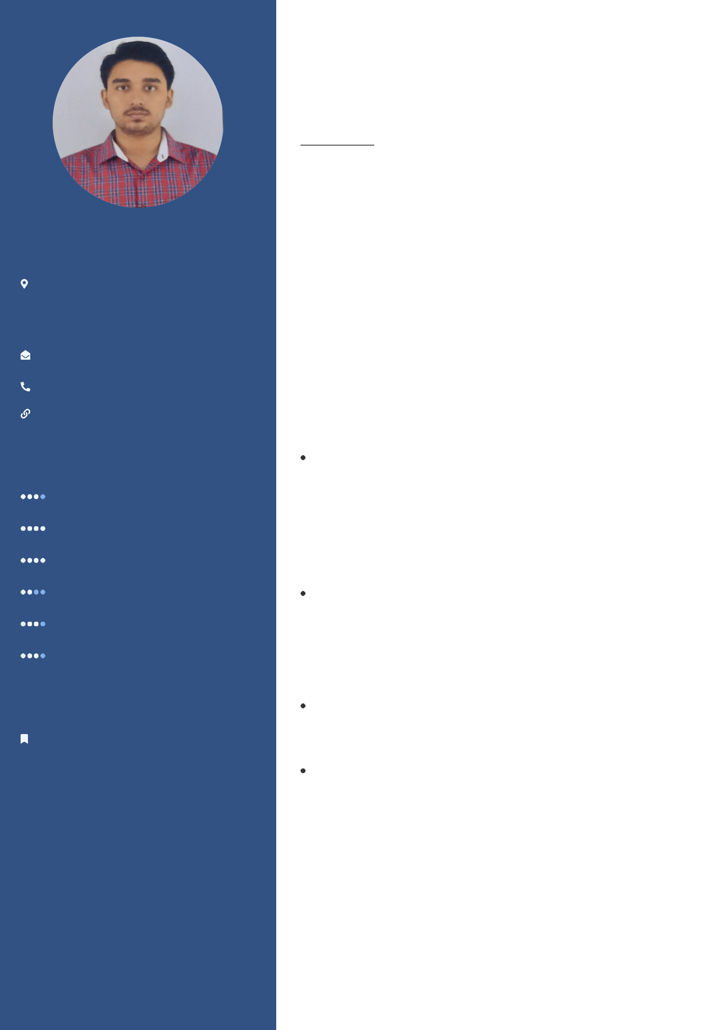

PERSONAL PROFILE

I am a goal oriented , determined and ambitious person with a passion for Python, am a good learner and want to grow more in this field.

WORK EXPERIENCE

Robust Results Pvt. Ltd.

Full Stack with My SQL | Jun 2021 - Jul 2021

I have completed my 6 weeks course in this company on technologies HTML5, CSS3, JavaScript, Bootstrap, PHP, with MySQL.

Internshala

Programming with Python | Jul 2020 - Aug 2020

I have completed my training on Python, in a 6 week course which comprises of Basic Python , Application of Python and OOP.

PROJECTS

Built a Zoom Clone which is a online meeting ,web conferencing application which allows real time messaging using Node js ,Express ,Socket.io etc. in a three man team

Built a Blood Bank web application which allows user to order blood of different variety as well as can place order. One can also give in blood to a hospital if they want . Using Full stack , PHP ,SQL.

EDUCATION

Shri Ram Murti Smarak College Of Engineering Technology And Research

B-Tech in Computer Science and Engineering |  | | Aug 2018 - Aug
2022
 | Cumulative GPA: 7.42


Concentration: Database Management Systems

Relevant courses: Data Structures, Operating System

S S Prasad Public School

12th | Apr 2017 - Apr 2018

Percentage - 67.67%

Kids Corner Happy SR Sec. School

10th | Apr 2015 - Apr 2016

CGPA - 9.2

Organiser of our Annual Fest

