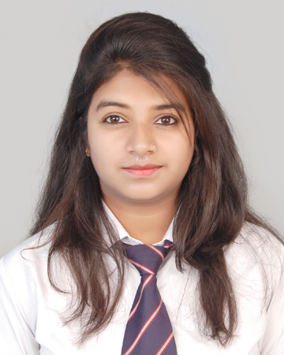
CURRICULUM VITAE

Arshiya Shaikh
66-Siddique inclave, Bareilly
+919045834186
E-mail : arshi.177.ar@gmail.com

CAREER OBJECTIVE
To learn and work effectively in an organization, which enables me to achieve not only the company's growth
objective but also maximize my career potential.

ACADEMIC QUALIFICATIONS

COURSES | INSTITUTE | BOARD/ UNIVERSITY | YEAR OF PASSING | PERCENTAGE / CGPA
B.TECH  (CS) | Shri Ram Murti Smarak College of Engg. , Tech.& Research , Bareilly, U.P | Dr. A.P.J Abdul Kalam Technical University | 2018 | 71.50%
XII | Bishop Conrad sr. sec. school,bareilly | CBSE Board | 2013 | 68.43%
X | Bishop Conrad sr. sec. school,bareilly | CBSE Board | 2011 | 7.6 CGPA

ADDITIONAL CERTIFICATIONS

- One month internship certification in PHP development from RANNLAB TECHNOLOGY, Noida.
- Completed a course on python from internshala.
- Certification of Bootcamp on python and deep learning with ShapeAI and Developers Student club.

WORK EXPERIENCE

Graduate trainee at Airports Authority of India,
Civil Airport, Pantnagar 263145
January, 2020 - January, 2021

Job description
During the period of job with airports authority I was the trainee in the IT Department.
There I learned about different technologies and softwares with which the organization deals with on the daily basis eg. GEMS Portal , AIMS Portal, SAP MM and SAP ESS Software etc.

In addition, I coordinated and organized other IT tools like Video conferencing , LAN connectivity, email confriguration, website Handling and many other problem handling in IT department.

AREAS OF INTEREST

- Software engineering
- Database Management System

TECHNICAL SKILLS
- C programming
- PHP
- HTML
- SAP MM
- SAP ERP
- Project Management

PROJECTS
- PROJECT TITLE : Personal Consultancy Services DURATION : 3 months
DESCRIPTION : The objective of the project is to overcome the problems
ORGANISATION : SRMSCET&R

- PROJECT TITLE : Online restaurant Management
DURATION : 3 months
DESCRIPTION : To develop a site to order our food online
ORGANISATION : SRMSCET&R

SUMMER TRAINING

- Advance Java from E-School, duration (11th June to 15th July ,2016)
- PHP Development from E-School, duration (5th June to 10th July, 2017)

CONFERENCE/ WORKSHOPS ATTENDED
- Workshop on ANDROID DEVELOPMENT organized by Robosapiens on February 28th & 29th, 2016.
- Attended two days workshop on IOT organized by i3indya Technologies held on 17th and 18th October, 2016.

EXTRA CURRICULAR ACTIVITIES

- Held the post of Placement Coordinator in SRMSCET&R, Bareilly.
- Secured certification and silver medal in pkube NBA.
- Secured a certification in software development Marathon held in SRMSCET&R, Bareilly.

HOBBIES
Chess, Journelling, Blogging and Watching Movies

PERSONAL INFORMATION
Father's Name : Mr. Shaikh Alamgir
Mother's Name : Mrs. Safiya Shaikh
Date of Birth : April 28, 1997
Languages : Hindi, English
Marital Status : Unmarried
Nationality : Indian

REFERENCES
Mr. Shailesh Saxena Mr. Akash Verma
HOD (CS Dept), Jr. Executive (CNS)
SRMS CETR IT Department Head
Bareilly, U.P Pantnagar Airport, Uttarakhand
shailesh.saxena@srmscet.ac.in 7309328320

DECLARATION
I hereby declare that all the details furnished above are true to the best of my knowledge and belief.

DATE- 20 September, 2021
PLACE: Bareilly (ARSHIYA SHAIKH)

