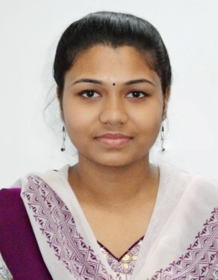
PCB Design,Testing & Team Managment Engineer
Tanushree Karan

58/11, Barik Para Road. Behala.
Kolkata – 700034
+91-8240207908/+91-9433185664
tanushreekaran5@gmail.com

Experience Summary
Overall 5years experience in electronics circuit designing and testing. Experience on PCB designing and assembling. Approximately 7 years experience as Technical Assistance in education sector. Managing team and training them on circuit designing, using several devices for measurement.

Experience
August 2013 – present
Techno India College of Technology – Technical Assistant (ECE)
- Project Assistance – Managing project team, guiding them to designing PCB layout using Matlab. Training them to design circuits using Circuitmaker, calculating components value and testing output, data sheet making.
- Guiding students to use lab devices such as CRO, Digital Oscilloscope, Analog & Digital Function Generator, Analog & Digital Multimeter, spectrum analyzer etc.
- Evaluating student performance, Laboratory maintenance, Laboratory Manual Maintenance, Project report data sheet maintenance, stock maintenance and sharing with team.
- Admission coordinator – Managing team, provide educational counseling to 12 pass out or graduate student with their guardian over telephone, video conference or face to face meeting.

June 2008 – July 2013
Sonodyne Electronics Co Pvt. Ltd. – Supervisor (R&D)
- Main job area was Electrical Testing, fault finding, trouble shooting and output checking using CRO, Function Generator and Multimeter etc.
- Amplifier, Pre amplifier testing, power supply, crosses over testing.
- Noise measurement (electrical & audio test) by noise meter.
- Listening test & value checking of woofer, sub woofer, twitter, transformer, coil before using those component in the project.
- Take final decision of rejection if required.
- Circuit Design, PCB layout design using CIRCUITMAKER, PORTEL and COREL DRAW.
- Component rating and value calculation according to project demand.
- Soldering of PCB mounted component or SMD mounted component in PCB in the very beginning stage of project.
- Product Quality Control – Giving final ‘OK’ approval after inspects all, from component soldering to cabinet fitting and final testing (electrical & audio both), of that product can go or can’t go for production.
- Project lead – I had team of 4-5 members. My main job role was managing every team member, report submission of each & every progress, data sheet checking, output checking and give all data & procedure of that product to product manager for production.
- Checking crossover PCB by Loud Speaker Software (LMS). By this software we can check the level of woofer twitter & mid. After that modify the level as per project demand.
- Maintain stock of Component store with stock book for component specification, manufacturer and quantity

Education
2017-2020
Maulana Abul Kalam Azad University of Technology, West Bengal – B-Tech (Electronics & communication Engineering)
2005 – 2008
West Bengal State Council of Technical Education – Diploma (Electronics & Telecommunication Engineering)

Training &Certification
- Training: Railway signalling system & communication (Eastern Railway-Liluah);
- Project: Smart Street Light System using ARDUINO, to save power consuming in highway, when cars are within 500 meter from lamp post, street light will ON else OFF.
- Computer: Diploma in IT (State Youth Centre Moulali)
- Computer: COURSERA certification on PYTHON BASICS from UNIVERSITY OF MICHIGAN.

Personal Details
Date of Birth: 08th August, 1986
Father’s Name: Bivas Karan
Mother’s Name: Bibhashree Karan
Marital status: Single
Aadhar Card No: 638423540527
PAN Card No: CCUPK2865B

Signature: Date:

