**Curriculum Vitae**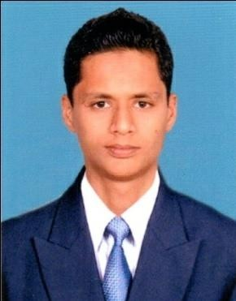

**MOHAMMED ANAS ZAHEER SHEIKH**

Mobile: - +91-9620033276

Email: - [anaszaheer56@gmail.com](mailto:anaszaheer56@gmail.com).

Address:- Zaheer Manzil,Dr U M Mulkadi Compound ,Near Masjid ,Shirva, Udupi District.

**CAREEROBJECTIVE:**

I look forward to associate myself with an organization providing me scope for growth, where there is opportunity to share, contribute and enhance my knowledge for the development of self and the organization. I believe in adapting for changes pertaining to sustainability along with survival.

* Passed B.Com (Vocational on Computer application) from Mangalore University in 2016. (65%)
* Passed Pre University from Dandathirtha Pre-University College Kaup in 2013. (54%)
* Passed S.S.L.C from Don Bosco English Medium School Shirva in 2011. (40%)

**CERTIFIED COURSE**

* Diploma in Microsoft Certified System Engineer ( MCSC) on 2017
* Diploma in tally .9 with GST on 2018

**WORK EXPERIENCE**

* Worked as Technical Support in SAARA Bmate technology for 2 months as a internship on 2019.
* Worked as System Expert in Value Point System Ltd (CBIC Saksham Seva Project) for 4 months as Backup on 2019
* Working as System Admin in Raasi Technologies Pvt Ltd (LIC OF INDIA EDMS Scanning Project) as a Backup

**SKILLS**

* MS Office Application
* Microsoft EPS
* Microsoft Office 365
* MS server2013
* Web Designing
* Computer languages
* Accounting
* Desktop Support
* Microsoft Windows OS
* Installation & Troubleshooting Of PC/Laptop
* Hardware Troubleshooting and Replacement
* Linux OS
* Installation Of Linux and Configuration
* MySql Adminstration Installation and Configuration
* Troubleshooting logon problem, boot process, and printing

**PROFESSIONAL VISIT**

* + - BASF - Katipalla , Mangalore Karnataka
    - KMF - Kulashekara, Mangalore Karnataka

**The Key Result Area:**

Faster learning strengths in group work, social interaction, character building and problem solving skills. Energetic, organized, positive and self-motivated with the ability to speak and write effectively.

**STRENGTHS**

* + - Good command over languages.
    - Good human relation.
    - Confident.
    - Quick learner.
    - Collaboration.
    - Positive Attitude.
    - Problem solving skill.
    - Self-motivation.
    - Leadership.
    - Teamwork.
    - Time management.
    - Decision making
    - Persuasive
    - Persistent
    - Patient

**PERSONAL STATEMENT**

* I believe that my greatest strength is teamwork and ability to adapt to new situations and solve any problem.

**PERSONAL DETAILS**

Date of Birth : 23rd March 1995

Nationality : Indian

Languages : English, Hindi, Urdu and Kannada.

Driving License : Two wheeler & Light Vehicle.

**DECLARATION:**

I hereby declare that the information furnished above is true to the best of my knowledge and belief.

Date:

Place:Shirva

(Mohammed Anas Zaheer Sheikh)