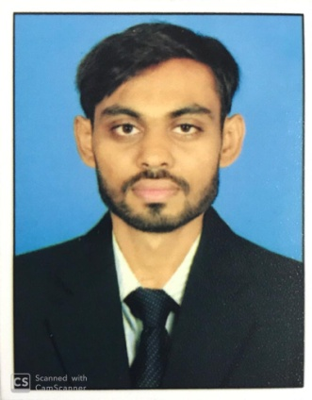Jaydeep G. Nakarani

LL.B. , B.COM

Address: - A-55, Rupali Society,

Nr P PSavani School, Hirabaug,

Varachha Road, Surat- 395008

C:\Users\Admin\Downloads\EMAIL.jpg : - jaydeepnakrani1994@gmail.com

C:\Users\Admin\Downloads\mobile.png : - (+91) 78789 65252

|  |
| --- |
| OBJECTIVE |

Looking for a position in a result oriented Organization where acquired skills and education will be utilized towards continuous growth and advancement and also provide opportunity to learn something new.

|  |
| --- |
| EDUCATIONAL QUALIFICATIONS |

|  |  |  |  |  |
| --- | --- | --- | --- | --- |
| Course | Name of Institute | University / Board | Passing Year | CGPA / % / SGPA |
| LL.B | Siddharth Law College Surat. | Veer Narmad South Gujarat University, Surat. | 2019 | 5.73/10 |
| B.Com | V. L. Shah College of commerce, Surat. | Veer Narmad South Gujarat University, Surat. | 2016 | 5.75/10 |
| 12th | Ankur High School, Surat. | G.H.S.E.B | 2013 | 60.86 % |
| 10th | Ankur High School, Surat. | G.S.E.B | 2011 | 53.80 % |

|  |
| --- |
| EXPERIENCE |

1. 3 Year Experience as a Accountant in CA ShrutiSavani & Associates.

Contect no. +91 93773 87232

|  |
| --- |
| SKILLS |

Special Skill in Accounting and Auditing,

Goods & Service Tex (GST) Account Assistant and Certificate from I.T.I. Surat,

MS office (Excel, Word, Power Point),

Computer Accounting (TALLY),

Self Motivated,

Ability to work under pressure.

|  |
| --- |
| PERSONAL DETAILS |

Father’s Name : Mr.GordhanbhaiNakarani

Date of Birth : 16th Sep., 1994

Gender : Male

Marital Status : Unmarried

Hobby : Book Reading, Listening music, Playing Cricket.

Languages Known : Gujarati, Hindi and English.

|  |
| --- |
| DECLARATION |

I am keen to continue my career and prepared to work hard in order to achieve my organization objectives and I hereby declare that the above information is true to best of my knowledge.