MURALI.M m.muralitharanmba@gmail.com.
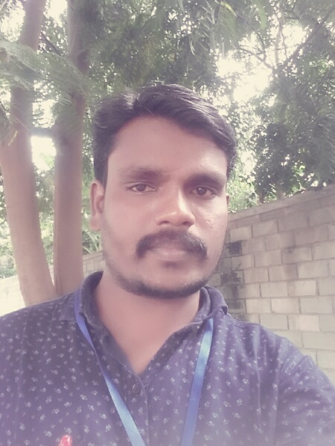
Contact no: +91- 85310 44880

CAREER OBJECTIVE:

To work in a challenging environment, where I could constantly learn and raise my career ladder with continuous updating of my knowledge and creativity, along with the Organization.

EDUCATIONAL QUALIFICATION:
COURSE | NAME OF INSTITUTION | BOARD/  UNIVERSITY | YEAR OF  PASSING | PERCENTAGE
MBA | REGIONAL CENTRE OF  ANNA UNIVERSITY,  TIRUNELVELI | ANNA UNIVERSITY | 2014 | 61.00(CGPA)
B.COM | BHARATHIDASAN UNIVERSITY OF TRICHY  . | GOVT.ARTS COLLEGE IN ARIYALUR. | 2012 | 66.90%
HSC | GOVT.HR.  SEC.SCHOOL,  T.PALUR | TAMILNADU  STATE BOARD | 2009 | 50.67%
SSLC | GOVT.HIGH.  SCHOOL,  T.PALUR | TAMILNADU  STATEBOARD | 2007 | 46%

ADDITIONAL COURSE

CO-CURRICULAR ACTIVITIES:( ADDITIONAL COURSE)

DBAA:DIPLOMA IN BUSINESS ACCOUNTING APPLICATION

(Completed DBAA Course at SRM Institute Of Computer Education, Ariyalur)

EXPERIENCE:
ORGANIZATION | DESIGNATION | EXPERIENCE
VELLAARU (P)LTD  (IFMR RURAL CHENEL) IN ARIYALUR . | ACCOUNTANT | 2 YEARS  (2014 - 2016)
RODAMINE APPAREL (P) LTD.  (Eastman Group of Companies)  In Tirupur | SENIOR INTERNAL AUDITOR  (Onwards in Rodamine Apperal (p)LTD | 5 YEARS  (2016 - till now )

Working Skills:
1.

Strength:
1.Decision Making
2.Leadership
3.Diversity
4.Tean Work

PERSONAL PROFILE:

DOB : 09/07/1992.
Gender : Male.
Father’s Name : A.MUNUSAMY
Address : Anaikkudam (main road)
Kodali Karupur(PO)
Udaiyarbalaiyam (TK)
Ariyalur (DT)
Languages Known : Tamil & English.

DECLARATION:

I hereby declare that the above informations are true to the best of my
Knowledge and belief.

DATE: Signature

PLACE: (M.MURALI)

