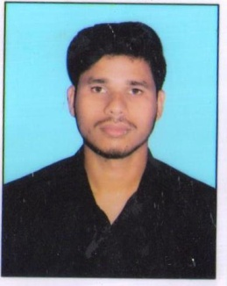

**RESUME**

**ASHU SINGH**

**Add:-** 98, Kaladanda Himmatganj

**Disst-** Allahabad **Pin-** 211016

**Contact No:-** 8765886778

**OBJECTIVE :-**

To work in a challenging enviroment by the help of skill deal to proof to myself an idea empolyes from by resective from firm seeking cares in a growth orient organized oppertunities for self development

**EDUCATIONAL QUALIFICATION:**

* High School (10th) passed from CBSE Board in 2014.
* Intermediate (12th) passed from CBSE Board in 2016.
* B.Sc Appearing from Allahabad State University.

EXPERIENCE:

* 3 Month Office work in Amazon.

**PERSONAL INFORMATION:**

Name **:** Ashu Singh

Date of Birth **:** 29/10/1999

Father**'s** Name **:** Mr. Shiv Prakash Singh

Gender **:** Male

Marital Status **:** Unmarried

Nationality **:** Indian

Religion **:** Hindu

Language **:** Hindi & English

**DECLARATION:**

I hereby declare that all the information given above is true to best of my knowledge and any false information will make my candidatures.

**Date :-**

**Place :** Allahabad  **(Ashu Singh)**