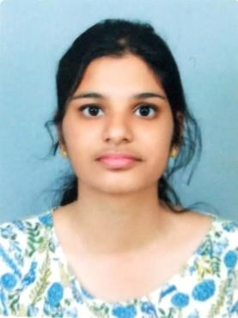DIYA K DAYAL

KALTHOONINGAL HOUSE

RAYHAN APPARTMENTS

PALARIVATTOM, COCHIN KERALA

diyakd1998@gmail.com

9946456946,9895753251

To get associated with the company where I can utilize my skills and gain further experience to explore new horizons while enhancing the company’s productivity and reputation.

EDUCATIONAL QUALIFICATIONS

|  |  |  |  |  |
| --- | --- | --- | --- | --- |
| Name of the degree | Pass out  Year | Institution | University/Board | CGPA/PERCENTAGE |
| B.Tech(CSE) | 2020 | SCMS SCHOOL OF  ENGINEERING AND  TECHNOLOGY | APJ ABDUL KALAM  TECHNOLOGICAL  UNIVERSITY | 7.74 |
| 12th | 2016 | ST.MARYS C.G.H.S.S | BOARD OF HIGHER  SECONDARY  EDUCATION | 91.58% |
| 10th | 2014 | ST.TERESAS C.G.H.S | KERALA BOARD OF EDUCATION | 96% |

WORK EXPERIENCE

1.Participated in 10 days internship program in ASP & web development conducted by Hexcore Technologies.

PROJECTS COMPLETED

1.RAILWAY RESERVATION SYSTEM

This project deals with online railway ticket reservation .

2.

AREAS OF INTEREST/EXPERTISE

PROGRAMMING: Basics of python,C,C++,Java

DATABASE: Basics of SQL

ACHIEVEMENTS AND CERTIFICATION

1. Participated in the Induction Programme(Bhavishya) conducted by ICT Academy of Kerala.
2. Volunteered in various flood relief activities in Ernakulam district.
3. Volunteered for monitoring and enforcing the green protocol rule suggested by the Ernakulam district collector at Thiruvairanikulam temple.
4. Attended a workshop on social entrepreneurship conducted by Technoglobe hub in association with Ragam, NIT Calicut.

TRAINING PROGRAMS ATTENDED

1. Attended a workshop on social entrepreneurship conducted by Technoglobe hub in association with Ragam, NIT Calicut.
2. Participated in 5 days internship program in android conducted by Aabasoft Technologies(India)Pvt.Ltd.
3. Participated in the Induction Programme(Bhavishya) conducted by ICT Academy of Kerala.

PERSONAL PROFILE

Father’s Name : K SDAYAL

Mother’s Name : PRASEEDA P B

Marital Status : SINGLE

Nationality : INDIAN

Date Of Birth : 24/06/1998

Hobbies : listening to music, watching movies, surfing internet.

Languages Known : English,Hindi,Malayalam

REFERENCE

1.Dr .Vinod P

Professor and HOD, Dean-Research and Publications, Department of Computer Science.

vinodp@scmsgroup.org

9497179735

2.Jency Rena N M

Assistant Professor, Department of Computer Science.

jencyrena@scmsgroup.org

9995327328

DECLARATION

I here by declare that the above-mentioned information is correct up to my knowledge and I bear the responsibility for the correctness of the above-mentioned particulars.

Date:08/08/2020 DIYA K DAYAL