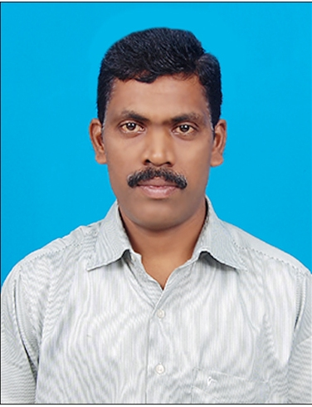CURRICULAM VITAE

**SATHURMUGAN. R**

**136, Main Road,**

**Mitta Mandagapattu,**

**Villupuram – 605 106.**

**Mobile # 9597111771**

Email: [rsathur@gmail.com](mailto:rsathur@gmail.com)

# Career Summary

# **19 years experience as an accountant with in depth knowledge of accounting tools, procedures and transactions. Seeking to work in a challenging environment and grow with the company to achieve its goal and get additional knowledge**

# Educational Qualification

* Completed B.com from Periyar Arts College, Cuddalore. (Madras University Branch)
* Diploma in Computer Application (6 months computer course in MS office and Tally)

**Computer Skills**

* Basics (MS-Word, MS-PowerPoint, MS-Excel) Internet Concepts, Ms-Access.
* Tally ERP9 and ERP Accounting software (Finance & Inventory Module)

# Accounting Skills

* Direct & Indirect Taxation knowledge in manufacturing industries, dealership and trading business,
* Handling independently Excise and returns filing,
* Handling both of Pondicherry and Tamilnadu State Sales Tax and monthly returns filing,
* Special assignment in Form CC submission, sales tax assessment, meet the excise audit, reply the scrutinizing letters from government department,
* Calculate TDS and Quarterly Returns filing, issuing Form 16A and Form 16
* Maintaining contractors and sub contractors,
* Service tax calculating and (ST–3) returns filing, (GTA and reverse charge mechanism)
* Petty Cash Handling and petty cash book maintaining,
* Fixed Asset Register maintaining,
* Assigning entries to proper accounts,
* Monthly provision entries made in the books for Payables,
* Utility payments following up (i.e, ESI, EPF, VAT, CST, EB bill, Telephone bill, Water tax, Professional Tax, etc.,
* Bank, Debtors & Creditors reconciliation and monthly Receivables , Payables reports to the management,
* Maintaining day-to-day cash inflows and outflows,
* Maintaining and Controlling the expenses of the Company
* Assist with auditors for accounts finalization, preparing Trail Balance and Balance sheet
* Assist with HR for payroll administration,
* Branch accounting and inter branch reconciliations,
* Making MIS Report

**Reason for leaving from Current Employer**

* I would like to work in corporate companies under pressure for achieving goal,
* I would like to get exposure in SAP accounting software and I have experience in ERP based, I will learn it quickly.

# Employment History

**Employer – I** : **Pearls Green Forest Limited**

Address : Maraimalai Adigal Salai, Pondicherry.

Designation : Accounts Assistant

Period : June 2001 to February 2004

**Employer – II** : **NIKITA CONTAINERS P LTD.**

Address : Vazhudavur Road, Kurumbapet, Pondicherry

Designation : Accounts & Office Assistant

Period : February 2004 to August 2010

**Employer - III** : **Precision Equipments (Chennai) Pvt. Ltd.**

Address : B#70/1, SIPCOT Industrial Park,

Irungattukottai, Kanchipuram.

Designation : Assistant Executive - Accounts

Period : August 2010 to February 2013

**Current Employer : Swashthik Caps Pvt Ltd**

Address : N0.A-72 & 73, PIPDIC Electronic Park, Thirubuvanai,

Pondicherry.

Designation : Senior Executive - Accounts

Period : February 2013 to till this date

**Personal Portrait:**

Father’s Name : **N. Radhakrishnan**

Date of Birth : 16.05.1977

Nationality : Indian

Marital Status : Married

Permanent Address : 136, Main Road, Mitta Mandagapattu,

Villupuram – 605 106.

**Declaration:**

I hereby declare that the above furnished details are true to the best of my knowledge and belief.

Signature

**PLACE: Pondicherry**

**DATE: 04-11-2019**