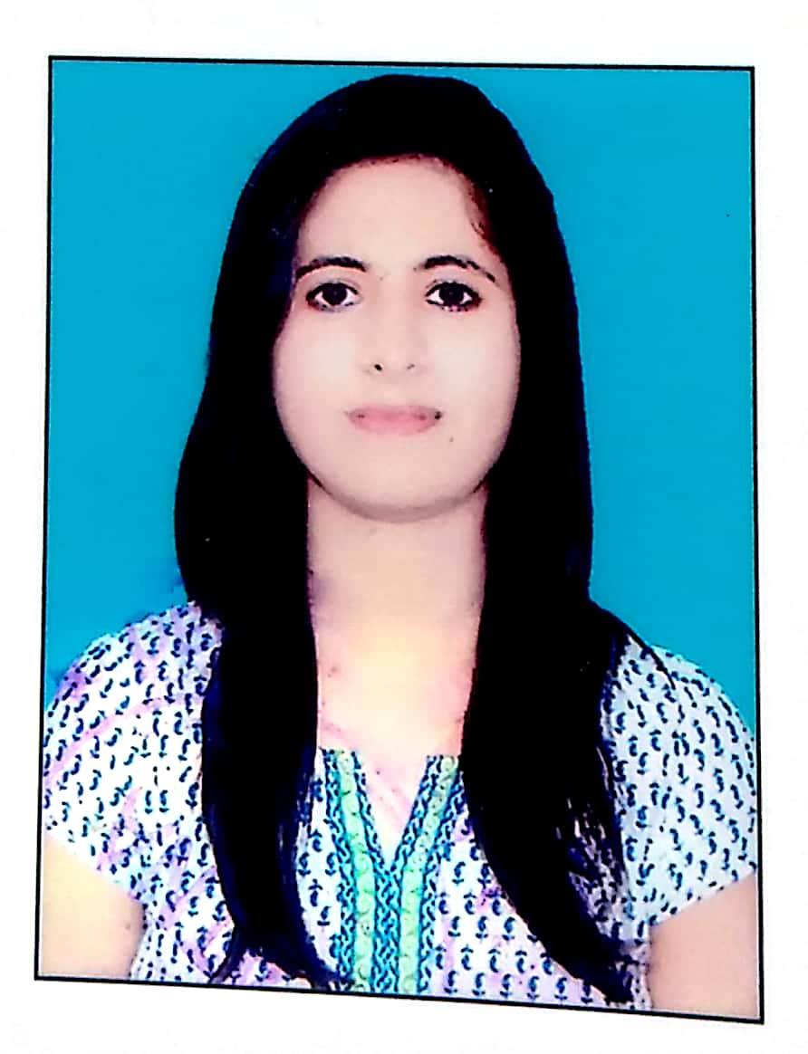
CURRICULUM VITAE
Name : Jyoti Upadhyay
Address: Ashok Nagar, MG Road Bangalore
Contact: 8521750056
Email: jyotiupadhyay1206@gmail.com
Apply for:

Educational Qualification:-

Course | Year of Passing | University/board | Aggregate (%/CGPA)
PGDBF | 2019 | Manipal university, Bangalore | 7.8
MCOM | 2017 | Patna University | 66%
BCOM | 2015 | Patna University | 78%
12TH | 2012 | CBSE | 70%
10th | 2010 | CBSE | 7.8

Work experience:-

Company name | Experience | Job role and responsibility in the company
ICICI BANK PVT LTD | 8 months | Deputy Manager 1

Technical skills:-
- Finacle
- CRM

Personal skills:-
- Good verbal and written communication skills
- Hardworking and willingness to learn new skills
- Ready to accept any challenges

Personal profile:-

Name: | Jyoti Upadhyay
Father’s Name: | Ashok Upadhyay
Date of birth: | June 12 , 1995
Place of birth: | Patna, Bihar
Marital status: | Unmarried
Nationality: | Indian

Languages known | Read | write
English | Yes | Yes
Hindi | Yes | Yes

Hobbies:-
- Dancing
- Traveling
- Reading Books(fiction)

THANKS

