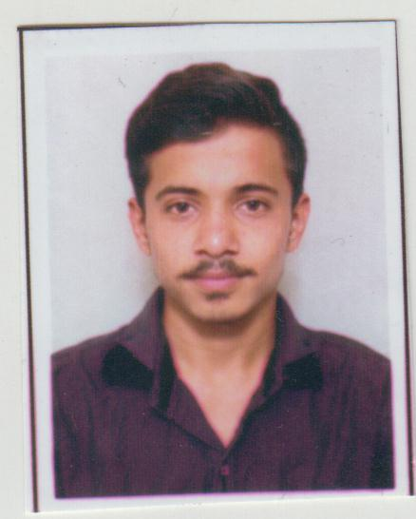
Resume

RAHULKUMAR JITENDRABHAI PANCHAL

32, JAY NARAYAN SOCEITY, RANOLI
VADODARA-391350
Email-rahulrn15199@gmail.com
Mo.7984255169
EDUCATION QUALIFICATION
Qualification | Institute/Board | Year Of Passing | Percentage/  grade
S.S.C | G.S.E.B | March-2013 | 65%
H.S.C | G.S.H.E.B | March-2015 | 55%
B.COM | HD  M.S.UNIVERCITY S | April- 2019 | 51%
M.COM | IIII IGNOU | PURSUING
EXPERIENCE
COMPANY NAME | POST | EXPERIENCE
ORION PACKART | ACCOUNTANT | 3 YEAR
INDIYUM SNACKS | ACCOUNTANT | 2 YEAR

PERSONNEL PROFILE

- Date of Birth : 01/05/1999
- Nationality : Indian
- Gender : Male
- Marital status : Un Married
- Language known : English, Hindi, Gujarati,

- Hobbies : Cricket, Reading

- Key skills : Accounting, data entry, Invoicing, Net banking online
Payment, MS Excel or MS word good working
- Computer
Knowledge : Basic computer skills & operating system
Tally ERP-9
RAHUL PANCHAL

