**RESUME**

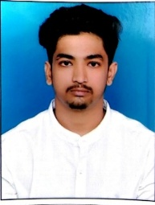**DEEPAK PATIL** BE (CIVIL ENGINEER)

Contact : 7411451767

E-mail : dp95354@gmail.com

Present Address :- Station road Jadar Galli Vijaypur 586104

**CAREER OBJECTIVE**

To work in a firm with a professional work driven environment where I can utilize & apply my knowledge, skills which would enable me as a fresh graduate to grow while fulfilling organization goals.

**BASIC ACADEMIC CREDENTIALS**

|  |  |  |  |  |
| --- | --- | --- | --- | --- |
| **Qualification** | **Board** | **Institution/ College/School** | **Year** | **Percentage** |
| BE (CIVIL ENGINEERING) | VTU | SECAB INSTITUTE OF ENGINEERING & TCHNOLOGY,  VIJAYAPUR-586109 | 2016-2019 67% | |
| DIPLOMA (CIVIL ENGINEERING) | DTE | BLDE A’s POLYTECHNIC, VIJAYAPUR-586104 | 2013-2016 | 64% |
| SSLC | SEEB | V. B. DARBAR. HIGH SCHOOL VIJAYPUR 586101 | 2008-2013 | 50% |

**PROJECT REPORT**

* STUDY OF CONTRUCTION OF AIRPORT.
* STUDY OF CONCRETE STRENGTH PROPERTIES BY USING SILICA FUME.
* SEMINAR ON DESIGN OF AIRPORT.

**COMPUTER SKILLS**

* General Basics Of Computer Hardware & Software
* Good in using ms office (ms-world, ms-PowerPoint)
* AUTOCAD