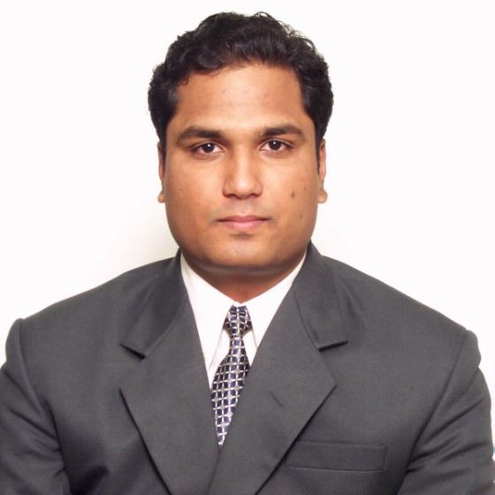
Samir Inamdar- MBA
State Head (DGM ) - NORDUSK LED
Revenue Generation | GTM Strategy Formulation | On Job Training | Standalone Outlets | Roi Mgt |
+91- 9595599000 / 9158242555.  Samir.Inamdar2007@gmail.com - Pune - 4110 44- INDIA
 linkedin.com/in/samir-inamdar-87a844172

Profile Summary
Area of Excellence
Sales & Distribution Management
Market & Competitive Analysis
Inventory Management
Corporate Sales - B2B / B2C Sales
Planning, Budgeting & Forecasting
ROI Return on Investment Management
Treasury  Off- take Management
People / Team Management
Merchandising & Promotion  Atl  Btl Activities
Relationship Management
Team Management
Key Accounts Management / Project Sales
Strategic Management
Regional Operations
Infrastructure Setup
On Job Training
Dynamic and diligent professional with successful career span of 15+ years predominantly in steering business development, sales & marketing Customer Satisfaction with renowned business organizations of FMCG, FMCD. Telecom & DTH
Distinction of having worked with various reputed brands including Nestle India Ltd, UB group, Vodafone, Tata Sky, Reliance, Syska in different regions in India including M.H. & Goa currently spearheading as State Head(DGM) with Nordusk LED based out at Pune.
Achieved top-line targets (volume and revenue) with eye on profits; negotiated terms of business with channel partners covering margins, Stock Keeping Unit (SKU) range, product display, in-store brand visibility and payment terms.
Defined product/channel marketing strategy, including development of channel marketing activities in accordance with overall business goals and objectives
Managing Distributors Return on Investment (ROI) by rationalizing Investments, budgetary control and driving efficiency of costs leading to consistently growing business

WORK EXPERIENCE


State Head (DGM ) Maharashtra & Goa(ROM)
NORDUSK LED. June 19 - present
Key Result Areas
- Monitoring 1 ASM + 6 Sales Officers managing 7 Distributors covering Retail Sales & Project Sales final execution of New Product launch  rollout, channel activations, GTM strategy and trade marketing initiatives and full year business outlook for the product, Develops trade marketing budgets as per brand / channel /region and ensures standards to measure and monitor trade spends, Identifies and develops vendors to support in design and development of marketing/promotion initiatives / merchandizing elements, arranging Dealers Meet, Architect meet Interior Designers, Construction Sites & arranging Events & Promotions to increase sale in the territory.
- Monitoring primary & secondary, Create KPI for the Sales/Distribution & Marketing Team and Evaluate. Conduct Business Analysis, Looking after all the Sales and Distribution of Lightning Segment.
- Overseen customer account management, including negotiating contracts and agreements to maximize profit Overseeing all Sales/Distribution and Marketing-related activities, Pricing/ Promotion Decision.
- Creation of Sales/Distribution & Marketing & GTM strategies/Cost to Sales Ratio for each Department. Taking Care of New Product Development. Price/Place/Promotion Decision. Use of Social Media in Marketing Plan.
- Managing Distributors/Dealer Return on Investment (ROI) by rationalizing Investments and driving his secondary sales
Senior Manager Rest of Maharashtra (ROM)

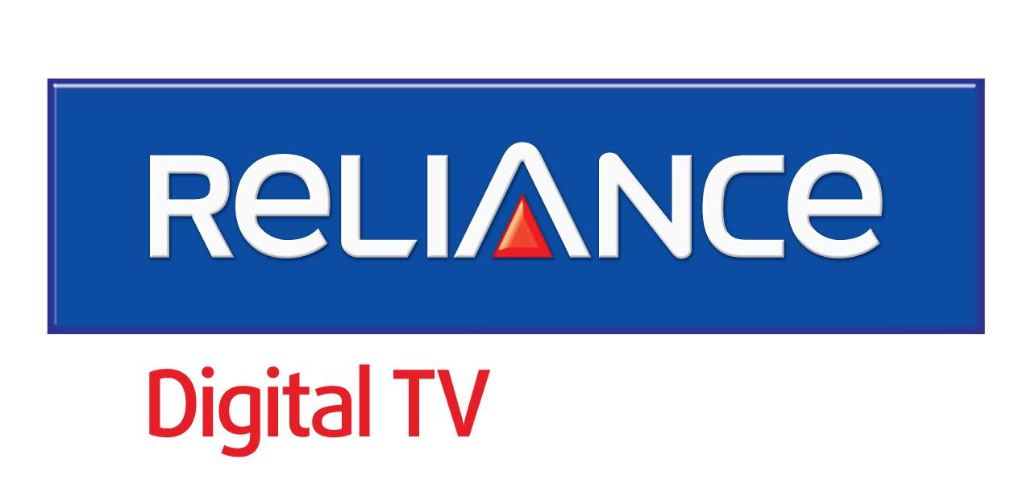
RELIANCE DIGITAL TV. May16Jun19
GROWTH PATH
State Head - 2018 - 2019
Cluster Head - 2016-2018
Key Result Areas
- Responsible for ROM territory for Retail Trade, Large Format Stores, and Standalone formats Sales Operations.
- Re-launched Big-tv as Independent TV in Maharashtra with 4 ZD, 45 SSD my total billing is 2 cr.
- Increased Revenue of ER from 1.05 cr TO 1.61 cr within 2 months.
- Expanded span of distribution and appointed distributors for better network engagement with an increase of 1050 new dealers in Pune, despite shortage of odu material and other material constraints maintained customer satisfaction which in turn reduced churn of customers, FTR WAS 7%, NR % was below 10% which is well within set targets.
- LMRT and LDO were effectively used as a retention tool due to which this category saw a 27% growth.
- Qualified 100% of my ISP in LCM ver 1 and 2, Maintained Repeat SR < 3 % and installation TAT 100%.
- Implemented RBM validation and reverse logistics successful..


Sales Manager Pune
SYSKA LED Lights July15- Apr16
Key Result Areas
- Market blitz activity done in pune and pcmc area which increased the width and depth of product.
- Built a strong distributor infrastructure in upcountry market and increased distributor count from 8 to 12.Handling a team of 3 TSI and 10 Sales officers ( on roll), Revenue Doubled from 1.5cr to 3 cr. Pune contributes to 50% share in total ROM sale, Increased market share in bulb and T5,total market share is 18%, Retailer meets done in which we bagged 1 cr business in one day during this event. Currently my area is at no 1 position in ROM.

Assistant Manager Pune & Pcmc
TATA SKY LTD May11- June15
Key Result Areas
- Handled 5 distributors and a team of 2 Tsi and 8 FOS.
- Won award for outstanding performance for Q3 2014-15 in MH2 Urban Circle (Maharashtra& Goa).
- Was Promoted from Sr Area trade sales Incharge to Assistant Manager.
- Appointed 4 new distributors and increased market share from 35 % to 57% making Tatasky leader brand in Pune and pcmc city. Activations- 800 and revenue recharge- 1.6 cr, Increased HD penetration from 45% to 75%. And outlet base from 350 to 600 outlets, Launched TSK 999 in my zone, got an increase of 25% in activations post launch.
- Stopped infiltration in my area..

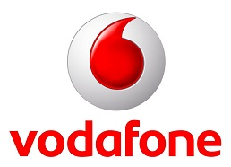
Retail Sales Manager Pune
VODAFONE Cellular Ltd March08-May11
Key Result Areas
- Handling area of MRR 1350, UEO 470, UAO 300,URO 580, Area rev is 1.5 cr per month with a team of 2 Distributor and 10 salesmen, Channel expansion, alternate channel development, sales process implementation, channel automation, MIS, Market Research, Competitor tracking, tariff/product acceptability /viability etc.
- Responsible for conceptualizing & implementing marketing initiatives like road shows, trade/consumer promotions, channel meets outdoor visibility, handset bundle offers, brand alliances, churn control, Ensure quality manpower adequacy, higher measure of customer satisfaction & continued business growth at company/distributor/franchisee levels.
NOTEWORTHY ACHIEVEMENT
- Won CIRCLE COMBAT award (Maharashtra& Goa) for the year 2009-2010 for good performance.
- Appointed new distributor and increased MRR from 900 to 1300, Launched Campus Pack successfully in my zone, got an increase of 50% in activations post launch, Stopped infiltration in my area
- Score kya Hai (SKH) an Maharashtra & Goa sales activity successfully implemented.
- Zero UUS underutilized sites in my zone, attained 2nd position by beating IDEA (on basis o f switch hit).


Sales Officer South GOA, Pune
NESTLE INDIA LTD Sep05 Feb08
Key Result Areas
- Handling a team of 5 distributors and 15 salesman with a turnover of 1 crore
- Drive Numeric Distribution & expand new outlets & Wholesalers, Claim Management Execute high-class visibility as per defined norms across retails outlets & Wholesalers, Manage inventories, FIFO, freshness of stock & Inventory Health Index as per company norms, To ensure continuous availability and regular rotation, Taking care of route operations
- To create secondary claim to company, promote in shop activities, Planning and executing sales promotions activities to create the Awareness of the Product. Initiatives were taken for better training - for sound product knowledge, review monthly meetings, get together to reward the performers and to motivate underperformers.
- Received Super Achiever award for the month of Nov 05 and also for the period of July 07 to Dec 07.


Territory Sales Executive Pune
UB Group July03  Sep05
Key Result Areas
- Handled 3 Distributors along with 8 salesmen for city and rural coverage in my area of Pune district of Maharashtra.
- Top Sales Performer consecutively for 2 quarter and for the year 2003 in whole of Maharashtra.
- Made changes in system which was strictly followed by the people to check Duplication, which in turn led to smooth sales function..


Sales Executive Pune
Cadbury India Limited Sep02 - June03
Key Result Areas
- New Channel Development (non conventional outlets, other than Trade O/L)
- Handling agencies, Corporate selling. Primary & Secondary , Roi Management

Education
- MBA from Pune University (2001- 2003)- First class with Distinction- DYPIMR.
- Bachelor of Commerce ,First class, from BMCC, Pune University.
- SSC - Kamalnayan Bajaj School, distinction , Pune, Maharashtra board

It Skills + Personal Details
- Well versed with MS Excel, MS Word, , MS PowerPoint, Pivot Table, V Look-Up & Internet Application.
- Well versed with the implementation of Mobile Solution to GT & Modern Trade
- Windows (98, 2000, XP, Vista)Internet Application & Ecommerce certification done
- Languages English, Hindi, and Marathi DOB: 16th Nov 1976

Place: - - Samir Inamdar

